Thrive!® -

People’s Guide To A Thriving Future

[For All Forever]

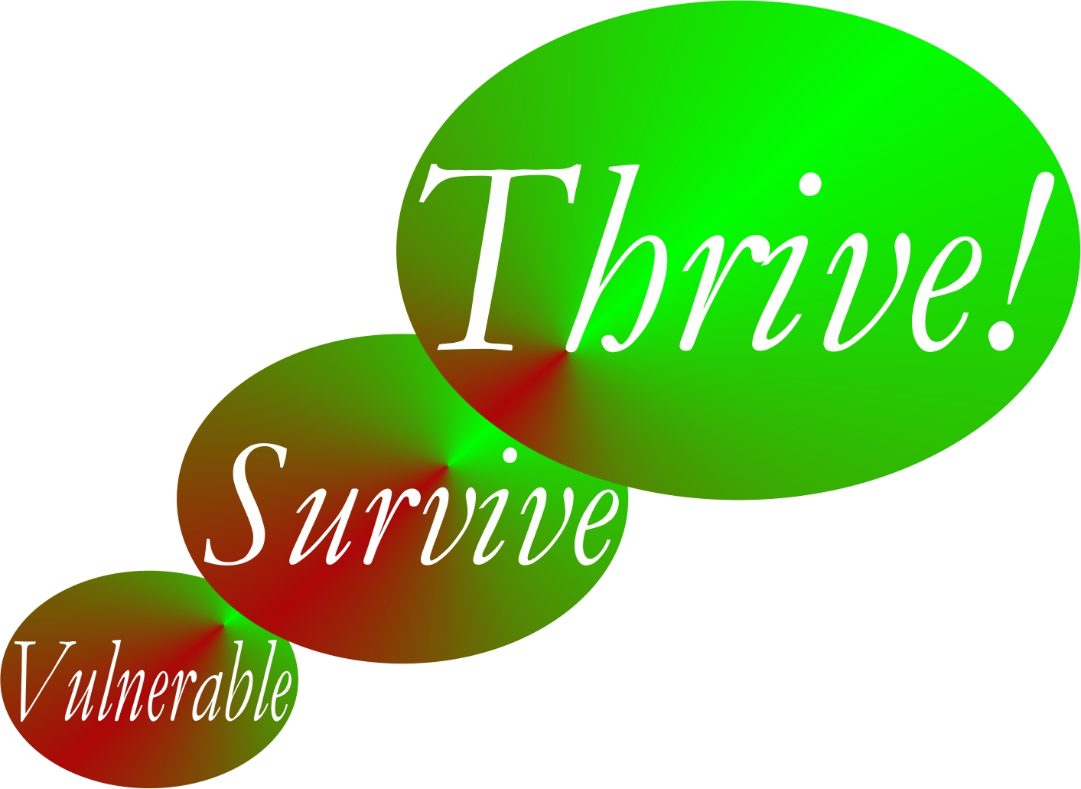

by

Gary “Chris” Christopherson

Founder, Thrive!® - Building a Thriving Future for All Forever
Founder, HealthePeople® - Building a Healthy and Thriving Future

Nelson, WI University Park, MD

Copyright © 2014 Gary Chris Christopherson

All rights reserved.
Thrive!® - People’s Guide To A Thriving Future
[For All Forever]

Complete Guide to a Thriving Future  [With Examples and Worksheets] | Complete Guide Page
Chapter 1: How to use this People’s Guide.
How to use People’s Guide to help you and your family and friends, community, country and world survive and thrive.
Chapter 2: What a thriving future will be.
What your life and our world will be in a thriving future where all survive and thrive forever.
Chapter 3: Why you and all of us must care about a thriving future.
Why you and we must care about a surviving and thriving future for you, friends and family, community, country, and world.
Chapter 4: How you and your family and friends can thrive.
How to build, achieve and sustain a surviving and thriving future for you and family and friends.
Chapter 5: How you and your community can thrive.
How to build, achieve and sustain a surviving and thriving future for you and your community.
Chapter 6: How you and your country can thrive.
How to build, achieve and sustain a surviving and thriving future for you and your country.
Chapter 7: How our world can thrive.
How to build, achieve and sustain a surviving and thriving future for our world.
Chapter 8: How the Thrive! Endeavor, you and all of us together, builds a thriving future.
How Thrive! Endeavor, you and all of us together, builds, achieves and sustains a surviving and thriving future for all forever.
Appendix: Thrive! Next Generation Toolkit.
Strategy, policy and tools for creating and sustaining large, positive change and building a thriving future.
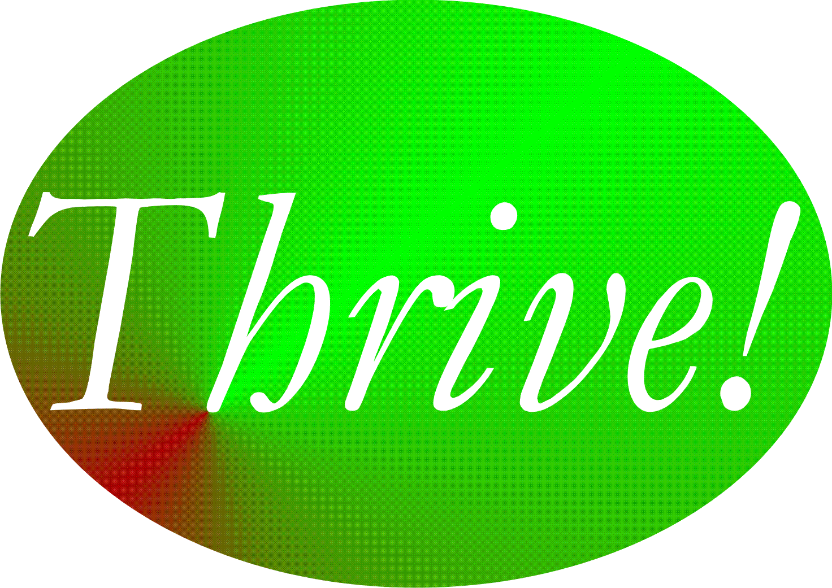

Chapter 5: How you and your community can thrive.
How to build, achieve and sustain a surviving and thriving future for you and your community.

Why you and your community can.
Thrive!
Keep in mind that we are more capable than any time in human history. We can build a thriving future by effectively and collaboratively using all available knowledge and tools, including “next generation” Thrive! strategy and tools. Next generation Thrive! is different and better than anything in human history. It is achieving a thriving future at each level. It understands that people’s behavior, including yours, makes (or breaks) a thriving future. It helps people, including you, achieve the behavior that in turn achieves a thriving future at each level and for all forever.

You and your community can have a surviving and thriving future. To get to that future, keep in mind that each community is different with a different future already beginning. Whether that future appears bad or good, each community can do better. To build a better future, the Thrive! strategy and tools has been used successfully at the personal level and on larger scales (community, country). They can work for you and the community you care about. As they have for others, this strategy and these tools can help you and your community build, achieve and sustain a surviving and thriving future.

Why you and your community must.

You and your community must have a surviving and thriving future. Each community must do better whether that future appears bad or good. Why? Even those communities that have a good future are not fully thriving, are not likely to be fully thriving in the future, and are still facing uncertainties about the long term future. You and your community want and need a surviving and thriving future because your community’s future is endangered and because of our human need to survive and desire to thrive. What drives a community and its people is our human need to survive and desire to thrive now and in a sustainable future. Further, because your community’s people (past and present) have broken some part of your community and endangered its future, you and your community’s people (present and future) must help fix what is broken and build a survivable and thriving future for your community.

Why we all must and can do it together.

To build this better future, your community’s people and leaders should be partners in this endeavor from the beginning and through each step. Success is dependent on positive and effective leadership from your community’s leaders and people. How that leadership comes about is the subject of some debate. Some people argue for a leader driven approach where the leader creates the vision and motivation and the people join and/or follow. Some argue for bottom-up or self-organizing approaches where the people lead and the traditional leaders may or may not join and/or follow. Some argue for a collaborative approach where the traditional leaders and the people (also serving as leaders) jointly provide leadership, vision, motivation, strategy and successful execution. In general, the latter approach probably has the greater potential to create and sustain large, positive change and a surviving and thriving community.

Some communities will be geographic communities (including villages, towns, cities, counties and states). When feasible and when your community’s governments are a positive force, governments should be part of the leadership and be partners in building a surviving and thriving community. However, it is not sufficient for governments to be the only leaders in this endeavor. Non-governmental organizations need to be leaders. Private businesses need to be leaders. Individual people need to be leaders. To be successful, this needs to be a whole community (people and leaders) endeavor.

Key to success is the strong desire by you and your community to move your community from its current vulnerabilities through and beyond surviving to a sustained thriving future.

How to build, achieve, and sustain a surviving and thriving future for you and your community.

To build a surviving and thriving future for you and your community, Thrive! can be helpful to you and is laid out in the following “how-to”., The following “how-to” is a relatively basic “how-to”. The underlying principles and the strategy, models and tools apply to communities from small size and low complexity to very large size and very high complexity.

It is adapted from the Thrive! Next Generation Toolkit contained in the Appendix. It is customized to help you and your people build, achieve and sustain a surviving and thriving future. More is available in Thrive! - Building a Thriving Future - a manual providing greater depth on strategy and tools and available via www.Amazon.com or free download from www.ThrivingFuture.org.

Step 1.

Step 1. Current state of you and your community. The first major step is to understand the current state of your community.

a. What is your community? Let’s first go through what is your community today. A community can be defined by geography (for example, a neighborhood, a region), by political boundaries (for example, a village, town, city, county, state), or by common population characteristics (e.g. racial/ethnic, gender, economics, political view, similar mission, religion, labor, profession, business). It can be a combination of these.

For your community, what are its geographic boundaries and characteristics? Use Table 5.1 (end of chapter) to describe all of the following for your community. Its gender, age, racial, ethnic make-up. Lifestyle. Type of work. Financial situation. Food and drink. Housing. Protection (crime, environmental hazards). Education. Physical and mental health. Personal growth and development. Habitat (living environment, neighboring communities, part of what state, country, continent). Producing what. Climate. Sustainability.

Example. Community is an incorporated city of 400,000 people occupying 40 square miles in the middle of the country. Gender mix is 51/49 female/male; age mix approximates that of the country as a whole but with slightly higher percentage under age 25; racial mix approximates that of the country as a whole but with a slightly higher percentage of all minorities. Lifestyle mix is similar to most cities of its size. Mix of work is similar to that of country as a whole but with a slightly larger percentage of blue collar workers and light industry. Financial basis is similar to most cities of its size but with slightly higher resources coming from light industry. Food and drink is similar to most cities of its size. A wide range of housing is available for those with the means to purchase or rent; community has adequate housing supply. Protection comes primarily from city police force with some neighborhood watch groups. Education is similar to most cities of its size but with slightly lower college education level. Physical and mental health is similar to most cities but with slightly less occupationally related illness. Personal growth and development is similar to most cities but with slightly more job re-training. Habitat consists of a small river and lake, mildly varying terrain, and moderate deciduous tree cover; located in medium-sized state in country. City produces usual range of products and services for city of its size, slightly higher percentage of manufactured products, relatively healthy and well educated children and range of recreational activities. Climate is moderate with slightly higher percentage of rainfall, slightly lower percentage of sunlight, slightly lower temperatures than other cities in country. Sustainability is in question due to changing national and international economics.

b. How well is your community? How well (surviving and thriving) is your community? Use Table 5.2 (end of chapter) to describe how well is your community. How well is your community in terms of performing well? Being well-off (financially)? Being well nourished (food and drink)? Being well housed? Being well protected (exposures, crime)? Being well educated? Being physically and mentally well? Personally growing/developing well? Living within good habitat? Not being vulnerable? Producing personal and public goods? Living within a stable, positive climate? Being sustained?

Answering “yes” to all indicates current surviving and thriving. Though the “yes” answers are good, there is still future work to make sure this continues. “No” answers are bad and mean there is current and future work to be done.

Example. Community is performing okay with close to country’s average mix lifestyles for city of its size. Unemployment is a 1 percentage point lower than country; mix of work is similar to that of country as a whole but with a slightly larger percentage of blue collar workers and light industry. Financial condition of community is generally stable and sufficient to support public services; community has slightly higher percentage of blue collar workers who are facing potential outsourcing of jobs and declining union effectiveness. Food and drink is available but prices are 5% above average for country; community lacks sufficient sources of healthy food; low income people lack resources for healthy food and for food generally; community lacks sufficient resources to feed very poor. Housing for upper and middle income people is available and affordable; housing for low and lower middle income people is unavailable, unaffordable and inadequate. Community police force is above average for country; some neighborhood watch groups exist and help but not without some problems. Education availability and quality is similar to most cities of its size; community has slightly lower percentage of college educated. Physical and mental health is about average compared to most cities of its size; community has slightly less occupationally related illness; private health services are average but public health services are only 75% of other cities of its size. Personal growth and development is about the same as most cities but it has slightly more job re-training. Habitat is pleasant and fairly healthy. While community has much vulnerability, it is most vulnerable on job and income loss, affordable and healthy foods, affordable housing, public health services, and community revenues. Community produces usual range of products and services for city of its size, slightly higher percentage of higher quality manufactured products, above average percentage of healthy and well educated children and an above average range of recreational activities. Climate is good. Sustainability is in question due to changing national and international economics and potential job outsourcing.

c. What positively or negatively impacts your community? What positively or negatively impacts or is likely to impact you and your community’s surviving and thriving? Use Table 5.2 to describe all of the following impacts (positive and negative; current and future). What impacts your community’s performing well? Being well-off (financially)? Being well nourished (food and drink)? Being well housed? Being well protected (exposures, crime)? Being well educated? Being physically and mentally well? Personally growing/developing well? Living within good habitat? Not being vulnerable? Producing personal and public goods? Living within a stable, positive climate? Being sustained?

Positive impacts improve and/or sustain surviving and thriving. If they will continue, you probably can focus on other things. If they may or may not continue, your action is needed to make them continue and/or to develop other things to compensate. Bad impacts prevent or limit surviving and thriving. If they will not continue, you probably can focus on other things. If they may or may not continue, your action is needed to stop them or to avoid or minimize their impact.

Example. Community is impacted by external lifestyle exposures. Employment is impacted by changing national and international economics and push for job outsourcing to places with lower cost labor; union effectiveness is impacted by country-wide changes in unions; businesses are impacted by overall economic climate. Financial condition of community is dependent on continuing support from state and national revenues. Food and drink is available but prices are 5% above average for country due to lack of competition; country as a whole lacks sufficient sources of healthy food; higher prices mean low income people lack resources for healthy food and for food generally; community lacks sufficient resources to feed very poor due to cutbacks in state and country food support. Housing for upper and middle income people is available and affordable and is positive; housing for low and lower middle income people is unavailable, unaffordable and inadequate and is negative. Community police force is losing good officers to communities with more resources. Education availability and quality is under pressure due to cutbacks in state and country aid; community’s college educated are being drawn away by other communities and their higher pay. Physical and mental health services are impacted by high quality staff being recruited by other communities with higher pay; physical health is impacted by occupational health exposure; mental health is impacted by potential job losses due to outsourcing; public health services impacted by lower state and country funding. Personal growth and development is impacted by same forces as most cities of its size; pressure on jobs means more need for job re-training. Community has much vulnerability and is most vulnerable on job and income loss, affordable and healthy foods, affordable housing, public health services, and community revenues. Habitat is pleasant and fairly healthy and is only impacted by broader national environmental exposures. Community producing of products impacted by high competition from other communities and countries; producing healthy and well educated children is impacted by state and country program and funding; recreational activities are impacted by availability of community and personal resources which are impacted by jobs and external funding. Climate is good but is impacted by country and global changes. Sustainability is in question due to changing state and country funding, national and international economics, and potential job outsourcing.

d. What is near and long term future behavior of your community? How is your community likely to behave in the near and long term future. For example, will it behave (individual behavior; group behavior, overall community behavior) so as to protect/improve public services, help each other survive/thrive, protect/increase jobs, maintain/improve community environment, and/or sustain the community near and long term.

Use Table 5.2 to describe all of the following behaviors. How will your community behave with respect to performing well? Being well-off (financially). Being well nourished (food and drink)? Being well housed? Being well protected (exposures, crime)? Being well educated? Being physically and mentally well? Personally growing/developing well? Living within good habitat? Not being vulnerable? Producing personal and public goods? Living within a stable, positive climate? Being sustained?

Example. Community will perform okay with close to country’s average mix lifestyles for city of its size. Working will be similar to that of country as a whole but with a slightly larger percentage of blue collar workers and light industry. Community will continue to protect financial condition of community and supports public services; community will try to reduce outsourcing of jobs; union will try to increase effectiveness. Community will try to find sufficient sources of healthy food; low income people will continue to try to make do with a lack of resources for healthy food and for food generally; community will try to find sufficient resources to feed very poor. Upper and middle income people will live in housing that is available and affordable; low and lower middle income people will struggle to find and keep affordable and adequate housing. Community police force will continue protection above average for country; some neighborhood watch groups will continue but with some problems. Community will continue education availability and quality similar to or better than most cities of its size; community will try to hold on to and increase the percentage of college educated. Community will try to improve physical and mental health which is about average compared to most cities of its size; community will try to keep lowering occupationally related illness; community will try to improve private health services and public health services (beyond 75% compared to other cities of its size). Community will explore how to increase personal growth and development but especially job re-training. Community will try to address at least its major vulnerabilities. Habitat will likely be pleasant and fairly healthy. Community will try to protect its production of products and services, increase its percentage of higher quality manufactured products, increase its above average percentage of healthy and well educated children and increase its above average range of recreational activities. Community will explore what it can do collaboratively with other communities and countries to ensure climate is good. Community will explore how to ensure sustainability given changing national and international economics and potential job outsourcing.

e. Want more on your community’s future and behavior? At this point, you have a baseline with which to measure progress for your community. You have enough information to move to Step 2 and to develop strategy for you and your community. If you want more information before moving to strategy, you may want to use more of the tools and models already mentioned and the Thrive! Next Generation Toolkit (Appendix).

Step 2.

Step 2. Strategy to achieve you and your community’s surviving and thriving future. The next major step is to develop the strategy that will help you and your community build and achieve a surviving and thriving future.

a. What will your community be in the future? What will be your desired and/or likely future community? Use Table 5.3 (end of chapter) to describe the likely future. If there are any changes to your community that are desired or likely, take them into account. You may want to leave out parts of the community that should not or will not be part of your community. You may want to include future additions that should or will be part of the community (for example, the next neighborhood, the next village/town/city, the surrounding area, another interest group, another population).

With this updated information, what will be your community’s geographic boundaries and characteristics? Type of work/how people live. Financial situation. Food and drink. Housing. Protection (crime, environmental hazards). Education. Physical and mental health. Personal growth and development. Habitat (living environment, neighboring communities, part of what state, country, continent). Producing what. Climate. Sustainability. Update Table 5.3 with this information.

Example. Community will be an incorporated city with population increasing 2%/year from current 400,000 people still occupying 40 square miles in the middle of the country. Gender mix will still be about 51/49 female/male; age mix will continue to approximate that of the country as a whole but with slightly higher percentage under age 30; racial mix will have a 10% higher percentage of minorities than the country as a whole. Lifestyle mix will be similar to most cities of its size but with additional influence of under 30 population. Mix of work may be similar to that of country as a whole and with a similar percentage of blue collar workers and light industry due to recent losses due to outsourcing. Financial basis will be a bit lower than most cities of its size but with slightly lower coming from light industry. Food and drink will be similar to most cities of its size. A wide range of housing will be available for those with the means to purchase or rent; community will have an adequate housing supply. Protection will continue to come primarily from city police force with some decline in neighborhood watch groups. Education will be similar to most cities of its size but with a lower level of college educated. Physical and mental health will be similar to most cities but with less occupationally related illness and more job related stress. Personal growth and development will be similar to most cities but with substantially more job re-training. Habitat will continue to consist of a small river and lake, mildly varying terrain, and moderate deciduous tree cover; community will continue to be located in medium-sized state in country. City will produce usual range of products and services for city of its size, average percentage of manufactured products, relatively healthy and well educated children and slightly reduced range of recreational activities. Climate will likely continue to be moderate with slightly higher percentage of rainfall, slightly lower percentage of sunlight, slightly lower temperatures than other cities in country; community will be increasingly concerned about negative climate change. Sustainability will remain in question due to predicted changes in national and international economics.

b. How well should your community be in the near and long term future? How well should your community as a whole be in the future? Overall, it should be surviving and thriving. With this as a guide, you and your community choose the surviving and thriving future your community wants to build and achieve. The “Thrive! strategy” will help you accomplish that.

Use Table 5.4 (end of chapter) to describe how well your community should be. From you and your community’s view and to be surviving and thriving, indicate to what extent your community should be performing well. Be well-off (financially). Be well nourished (food and drink). Be well housed. Be well protected (exposures, crime). Be well educated. Be physically and mentally well. Be personally growing/developing well. Be living within good habitat. Not be vulnerable. Be producing personal and public goods. Be living within a stable, positive climate. Be sustained. Again, your community should be surviving and thriving.

Example. Community should perform well with close to country’s average mix lifestyles for city of its size. Unemployment should be 2 percentage points lower than country; mix of work should be similar to that of country as a whole and continue with a slightly larger percentage of blue collar workers and light industry. Financial condition of community should be generally stable and sufficient to support public services; community should have slightly higher percentage of blue collar workers but who are no longer facing potential outsourcing of jobs and declining union effectiveness. Food and drink should be available and affordable with prices 5% below average for country; community should have sufficient sources of healthy food; low income people should have adequate resources for healthy food and for food generally; community should have sufficient resources to feed very poor. Housing for upper and middle income people should be available and affordable; housing for low and lower middle income people should be affordable, available and adequate. Community police force should be in top 10% for country; some neighborhood watch groups should exist but without any significant problems. Education availability and quality should be in the top 10% of cities of its size; community should have slightly higher percentage of college educated. Physical and mental health should be in top 10% of cities of its size; community should have substantially less occupationally related illness; private health services should be in top 25% and public health services should be in top 25% of cities of its size. Personal growth and development should be substantially better than cities of its size and community should have job re-training in top 10% of its size. Habitat should be very pleasant and very healthy. Community should have much less vulnerability; community should greatly reduce its vulnerability on job and income loss, affordable and healthy foods, affordable housing, public health services, and community revenues. Community should produce a wider range of products and services for city of its size, a substantially higher percentage of higher quality manufactured products, a high percentage of healthy and well educated children and a range of recreational activities in the top 10% of cities of its size. Climate should continue to be good to very good. Sustainability should be ensured and no longer be in question in spite of changing national and international economics and potential job outsourcing.

c. What has to change externally and internally to achieve your community’s thriving future? What has to change externally (outside your community) and internally (within your community) to progress from your community’s current status to achieve your desired surviving and thriving status? In Step 1, you identified what positively and negatively impacts or is likely to impact your community. Update those, including any changes to your future community from Step 2a.

Given those, what has to change to achieve a surviving and thriving future? Use Table 5.4 to describe all that has to change externally and internally for the following. To achieve performing well? Being well-off (financially)? Being well nourished (food and drink)? Being well housed? Being well protected (exposures, crime)? Being well educated? Being physically and mentally well? Personally growing/developing well? Living within good habitat? Not being vulnerable? Producing personal and public goods? Living within a stable, positive climate? Being sustained?

Good changes improve and/or sustain surviving and thriving. Bad changes prevent and/or limit surviving and thriving.

Example. Internally, community should perform better than it has. Internally, community needs to gain more employers to get to 2 percentage points lower than country; community needs to gain more blue collar workers and light industry; internally, community employers should expand and add jobs. Externally, outside employers should locate new jobs in community. Internally, financial condition of community should be even better managed to be generally stable and sufficient to support public services; community should gain slightly higher percentage of blue collar workers; employers should avoid outsourcing of jobs and reducing union effectiveness. Externally, outside employers should locate new jobs in community. Internally, community, grocers and restaurants should make food and drink available and affordable with prices 5% below average for country; community, grocers and restaurants should have sufficient sources of healthy food; community should ensure low income people have adequate resources for healthy food and for food generally; community should add resources to have sufficient resources to feed very poor. Externally, retail and wholesale food sources should hold down prices and add more healthy foods; country and state should provide resources to ensure food affordability for low and lower middle income persons. Internally, community should make available housing for low and lower middle income people that is affordable, available and adequate. Externally, country and state should provide resources to build affordable housing and resources for lower middle and low income people to rent or buy a house. Internally, community should provide resources and management to ensure police force should be in top 10% for country; neighborhood watch groups should exercise good management to avoid any significant problems. Externally, country and state should provide resources to adequately supplement community police resources. Internally, community should provide resources and management to ensure education availability and quality in the top 10% of cities of its size; community should work to retain and increase the percentage of college educated. Externally, country and state should provide resources to adequately supplement community education resources. Internally, community and private and public health services should improve services so that physical and mental health should be in top 10% of cities of its size; community and industry should ensure having substantially less occupationally related illness; community and private health services should ensure private health services in top 25% and community should ensure public health services in top 25% of cities of its size. Externally, country and state should ensure affordability (cost and insurance) of health services. Internally, community should help ensure personal growth and development is substantially better than cities of its size; community should ensure job re-training is in top 10% of its size. Externally, country and state should provide additional re-training resources to supplement community. Internally, community should ensure habitat is very pleasant and very healthy. Externally, country and state should ensure habitat is very pleasant and very healthy. Internally, community should reduce its vulnerabilities with special efforts (as listed for other areas) to greatly reduce its vulnerability on job and income loss, affordable and healthy foods, affordable housing, public health services, and community revenues. Externally, country and state should reduce vulnerability country and state-wide with special efforts (as listed for other areas) to greatly reduce its vulnerability on job and income loss, affordable and healthy foods, affordable housing, public health services, and community revenues. Internally, community should ensure a wider range of products and services than other cities of its size, a substantially higher percentage of higher quality manufactured products, a high percentage of healthy and well educated children and a range of recreational activities in the top 10% of cities of its size. Externally, employers should bring more and a wider range of jobs and higher quality manufacturing; country and state provide added education resources; country and state add recreational resources to community. Externally, country and state work to ensure climate is good to very good. Internally, community ensures sustainability is no longer in question in spite of changing national and international economics and potential job outsourcing. Externally, country and state support policies that reduce outsourcing and protect jobs in community.

d. What actions by your community are needed to achieve its thriving future? What internal actions (by you and your community) and external actions (by others) are needed to bring about the needed external and internal changes (identified in “c”) that improve your community’s current status enough to achieve the desired surviving and thriving status? [See Figure 5.1]

External actions by others. There are very important external actions that are needed to support the Thrive! strategy. You already identified what has to change externally to achieve your community’s surviving and thriving future. What external actions by others will bring about the needed changes?

Use Table 5.4 to describe all the external actions to be taken.

Identify external actions by others that support good changes that will help improve and/or sustain surviving and thriving. If good changes are likely to occur, together with others support them. If good changes are not likely to occur, together with others support them and develop other good changes to compensate.

Identify external actions by others that stop bad changes that prevent or limit surviving and thriving. If bad changes are not likely to occur, together with others ensure they do not. If bad changes are likely to occur, together with others change them, stop them or avoid/reduce their impact.

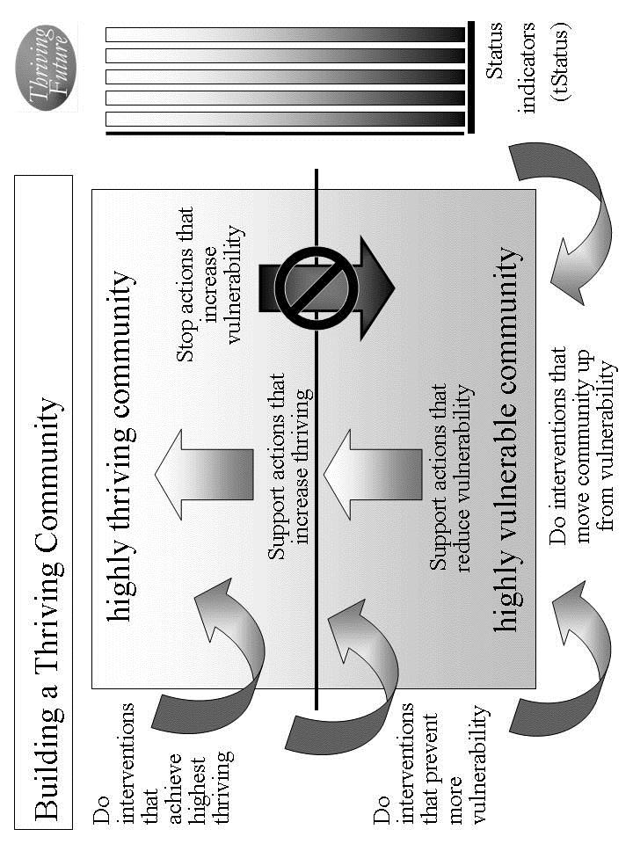Figure 5.1. Building a Thriving Community.

Example. Outside employers locate new jobs in community. Retail and wholesale food sources hold down prices and add more healthy foods; country and state provide resources to ensure food affordability for low and lower middle income persons. Country and state provide resources to build affordable housing and resources for lower middle and low income people to rent or buy a house. Country and state provide resources to adequately supplement community police resources. Country and state provide resources to adequately supplement community education resources. Country and state ensure affordability (cost and insurance) of health services by instituting cost constraints and providing affordable health insurance. Country and state provide additional re-training resources to supplement community. Country and state ensure habitat is very pleasant and very healthy by adding funding for public parks and preventive health programs. Country and state policies and programs reduce vulnerability country and state-wide with special efforts (as listed for other areas) to greatly reduce its vulnerability on job and income loss, affordable and healthy foods, affordable housing, public health services, and community revenues. Employers bring more and a wider range of jobs and higher quality manufacturing; country and state provide added education resources; country and state add recreational resources to community. Country and state work to ensure climate is good to very good through environmental policy and international agreements. Country and state execute policies that reduce outsourcing and protect jobs in community.

Internal actions by your community. There are very important internal actions by you and your community that support the Thrive! strategy. Individual community members and your community as a whole should support your strategy to ensure your community and each community member are performing well. Being well-off (financially). Being well nourished (food and drink). Being well housed. Being well protected (exposures, crime). Being well educated. Being physically and mentally well. Personally growing/developing well. Living within good habitat. Not being vulnerable. Producing personal and public goods. Living within a stable, positive climate. Being sustained.

Use Table 5.4 to describe all the internal actions to be taken.

Identify internal actions by your community that support good changes that will help improve and/or sustain surviving and thriving. If good changes are likely to occur, support them. If good changes are not likely to occur, support them and develop other good changes to compensate.

Identify internal actions by your community that stop bad changes that prevent or limit surviving and thriving. If bad changes are not likely to occur, ensure they do not. If bad changes are likely to occur, change them, stop them or avoid/reduce their impact.

Example. Community provides incentives and community support to gain more employers to get to 2 percentage points lower than country and to gain more blue collar workers and light industry; internally, community employers expand and add jobs. Community recruits outside employers to locate new jobs in community. Community better manages financial condition to be generally stable and sufficient to support public services; community retains and recruits employers to gain slightly higher percentage of blue collar workers; employers avoid outsourcing of jobs and reducing union effectiveness. Community provides incentives to outside employers to locate new jobs in community. Community, grocers and restaurants make food and drink available and affordable with prices 5% below average for country; community, grocers and restaurants provide sufficient sources of healthy food; community provides support to low income people to ensure adequate resources for healthy food and for food generally; community adds resources to have sufficient resources to feed very poor. Community with other communities presses retail and wholesale food sources to hold down prices and add more healthy foods; community with other communities presses country and state to provide resources to ensure food affordability for low and lower middle income persons. Community should make available housing for low and lower middle income people that is affordable, available and adequate. Community presses country and state to provide resources to build affordable housing and resources for lower middle and low income people to rent or buy a house. Community provides resources and management to ensure police force is in top 10% for country; neighborhood watch groups exercise good management to avoid any significant problems. Community presses country and state to provide resources to adequately supplement community police resources. Community provides resources and management to ensure education availability and quality in the top 10% of cities of its size; community works to retain and increase the percentage of college educated. Community presses country and state to provide resources to adequately supplement community education resources. Community and private and public health services improve services so that physical and mental health should be in top 10% of cities of its size; community and industry ensure having substantially less occupationally related illness; community and private health services ensure private health services in top 25%; community manages and provides resources to ensure public health services in top 25% of cities of its size. Community presses country and state to ensure affordability (cost and insurance) of health services. Internally, community helps ensure personal growth and development is substantially better than cities of its size; community adds resources to ensure job re-training is in top 10% of its size. Community presses country and state to provide additional re-training resources to supplement community. Community implements policies to ensure habitat is very pleasant and very healthy. Community presses country and state to ensure habitat is very pleasant and very healthy. Community reduces its vulnerabilities with special efforts (as listed for other areas) to greatly reduce its vulnerability on job and income loss, affordable and healthy foods, affordable housing, public health services, and community revenues. Community presses country and state to institute policies and programs that reduce vulnerability country and state-wide with special efforts (as listed for other areas) to greatly reduce its vulnerability on job and income loss, affordable and healthy foods, affordable housing, public health services, and community revenues. Community and private sector ensure a wider range of products and services than other cities of its size and a substantially higher percentage of higher quality manufactured products; community ensures supportive resources to help ensure a high percentage of healthy and well educated children; and community provides resources to ensure a range of recreational activities in the top 10% of cities of its size. Community recruits employers to bring more and a wider range of jobs and higher quality manufacturing; community presses country and state to provide added education resources; community presses country and state to add recreational resources to community. Community presses country and state to ensure climate is good to very good. Community ensures sustainability is no longer in question in spite of changing national and international economics and potential job outsourcing. Community presses country and state to support policies that reduce outsourcing and protect jobs in community.

e. Overall Thrive! strategy and actions. Your overall Thrive! strategy and actions need to be documented and agreed to by your community. This will be your community’s Thrive! Strategy and Action Plan. Different members of your community will take on different responsibilities. For each action, designate who of your community will do what to/with whom, where, when, and with what result. [See example below.] Use Table 5.4 to document these actions and responsibilities. [See example table below.] Make sure you have all the actions that are needed to build, achieve and sustain a surviving and thriving community.

As the strategy is executed, you strategy, actions and results should be updated in your Thrive! Strategy and Action Plan.

Periodically, you and your community should do an evaluation - assessing your strategies/actions near and long term impact on near and long term surviving and thriving. When a) your strategies and actions are not building and sustaining a thriving future and/or b) there are changes in the external world and in your community, you and your community should adjust your overall Thrive! Strategy and Action Plan.

The key is to successfully execute your community’s Thrive! Strategy and Action Plan and to build a near and long term surviving and thriving future. Each and all must successfully carry out the assigned action. That is, each/all must successfully do what is required to/with whoever is required, where required, when required, and with what needed/desired result. A Thrive! Strategy and Action Plan is only as good as its successful execution and successful achievement of the desired outcome - a surviving and thriving future.

Example of a community surviving and somewhat thriving. [Who will do what to/with whom, where, when, and with what result?] See Example Thrive! Strategy and Action Plan in list and table below. With these actions, community would be surviving and doing better but would not yet have achieved full thriving.
External Actions: Outside employers locate new jobs in community within 12 months. Retail and wholesale food sources hold down prices to 1% increase for next 12 months and add more healthy foods on trial basis starting within 6 months; country and state provide resources this fiscal year to ensure food affordability for low and lower middle income persons. Country and state provide resources to build affordable housing and resources for lower middle and low income people to rent or buy a house. Country and state provide resources this fiscal year to adequately supplement community police resources. Country and state provide resources this fiscal year to adequately supplement community education resources. Country and state ensure affordability (cost and insurance) of health services by instituting cost constraints to less than 3% increase and providing affordable health insurance within 12 months. Country and state provide additional re-training resources this fiscal year to supplement community. Within 2 years, country and state policies and programs substantially reduce vulnerability country and state-wide with special efforts (as listed for other areas) to greatly reduce its vulnerability on job and income loss, affordable and healthy foods, affordable housing, public health services, and community revenues. Country and state ensure habitat is very pleasant and very healthy by adding 25% more funding this fiscal year for public parks and preventive health programs. Employers bring more and a wider range of jobs and higher quality manufacturing within 12 months; country and state provide added education resources this fiscal year; country and state add recreational resources this fiscal year to community. Country and state work to ensure climate is good to very good through environmental policy within 18 months and international agreements within 2 years. Country and state execute policies that reduce outsourcing and protect jobs in community within 12 months.
Internal Actions: Community provides property tax incentives and community support within 12 months to gain more employers to get to 2 percentage points lower than country and to gain more blue collar workers and light industry; community employers expand and add 10% more jobs within 1 year. Community recruits outside 5 new employers to locate new jobs in community within 2 years. Community better manages financial condition to be generally stable and sufficient to support public services starting next fiscal year; community retains and recruits employers to gain slightly higher percentage of blue collar workers (see above); employers avoid outsourcing of jobs and reducing union effectiveness over next 2 years. Community provides incentives to outside employers to locate new jobs in community (see above). Within 12 months, community, grocers and restaurants make food and drink available and affordable with prices 5% below average for country; community, grocers and restaurants provide sufficient sources of healthy food within 12 months; community provides support to low income people to ensure adequate resources for healthy food and for food generally within 12 months; community adds resources to have sufficient resources to feed very poor within 12 months. Starting immediately, community with other communities presses retail and wholesale food sources to hold down prices and add more healthy foods; starting immediately, community with other communities presses country and state to provide resources to ensure food affordability for low and lower middle income persons. Within 2 years, community should make available housing for low and lower middle income people that is affordable, available and adequate. Starting immediately, community presses country and state to provide resources to build affordable housing and resources for lower middle and low income people to rent or buy a house. Community provides resources and management this fiscal year to ensure police force is in top 10% for country; neighborhood watch groups exercise good management to avoid any significant problems starting within 30 days. Starting immediately, community presses country and state to provide resources to adequately supplement community police resources. Community provides resources and management this fiscal year to ensure education availability and quality in the top 10% of cities of its size; starting immediately, community works to retain and increase the percentage of college educated. Starting immediately, community presses country and state to provide resources to adequately supplement community education resources. Within 2 years, community and private and public health services improve services so that physical and mental health should be in top 10% of cities of its size; community and industry ensure having substantially less occupationally related illness within 2 years; community and private health services ensure private health services in top 25% within 2 years; community manages and provides resources this fiscal year to ensure public health services in top 25% of cities of its size. Starting immediately, community presses country and state to ensure affordability (cost and insurance) of health services. Community helps ensure personal growth and development is substantially better than cities of its size within 18 months; community adds resources this fiscal year to ensure job re-training is in top 10% of its size. Starting immediately, community presses country and state to provide additional re-training resources to supplement community. Within 1 year, community implements policies to ensure habitat is very pleasant and very healthy. Starting immediately, community presses country and state to ensure habitat is very pleasant and very healthy. Within 2 years, community substantially reduces its vulnerabilities with special efforts (as listed for other areas) to greatly reduce its vulnerability on job and income loss, affordable and healthy foods, affordable housing, public health services, and community revenues. Starting immediately, community presses country and state to institute policies and programs that reduce vulnerability country and state-wide with special efforts (as listed for other areas) to greatly reduce its vulnerability on job and income loss, affordable and healthy foods, affordable housing, public health services, and community revenues. Community and private sector ensure a wider range of products and services than other cities of its size and a substantially higher percentage of higher quality manufactured products within 12 months; community ensures supportive resources this fiscal year to help ensure a high percentage of healthy and well educated children; and community provides resources this fiscal year to ensure a range of recreational activities in the top 10% of cities of its size. Community recruits employers to bring more and a wider range of jobs and higher quality manufacturing within 12 months; starting immediately, community presses country and state to provide added education resources; starting immediately, community presses country and state to add recreational resources to community. Starting immediately, community presses country and state to ensure climate is good to very good. Within 2 years, community ensures sustainability is no longer in question in spite of changing national and international economics and potential job outsourcing. Starting immediately, community presses country and state to support policies that reduce outsourcing and protect jobs in community.

But, we want a thriving future for you and your community. To build, achieve and sustain a surviving and thriving future, the Thrive! Strategy and Action Plan should be more like the following example:

Example of you and your community surviving and thriving. [Who will do what to/with whom, where, when, and with what result?] Starting immediately for you and your community, people, business/industry, private organizations (local, country), governments (local, country) and international organizations) build, achieve, and sustain a surviving and thriving future for you and your community, including:
- Performing well. Starting immediately for you and your community, people, business/industry, private organizations (local, country), governments (local, country) and international organizations act to ensure, within the next 10 years, a) all (who are able and not appropriately retired) can work and earn a living income sufficient to survive and thrive and b) all have sufficient resources for and are living, recreating, learning so that they are surviving and thriving to maximum extent feasible.
- Being well-off (financially). Starting immediately for you and your community, people, business/industry, private organizations (local, country), governments (local, country) and international organizations act to ensure, within the next 10 years, a) all have sufficient income/resources to survive and thrive and b) all governments have sufficient resources to provide needed (supporting surviving) and desired (supporting thriving) public programs and policies.
- Being well nourished (food and drink). Starting immediately for you and your community, people, business/industry, private organizations (local, country), governments (local, country) and international organizations act to ensure, within the next 10 years, that all have access to, be able to afford and consume healthy foods enough to survive and thrive.
- Being well housed. Starting immediately for you and your community, people, business/industry, private organizations (local, country), governments (local, country) and international organizations act to ensure, within the next 20 years, all have access to, be able to afford and live in adequate and preferably high performing housing that supports surviving and thriving.
- Being well protected (exposures, crime). Starting immediately for you and your community, people, business/industry, private organizations (local, country), governments (local, country) and international organizations act to ensure, within the next 10 years, a) environmental exposures in home, workplace and elsewhere are minimized so as to not prevent surviving and thriving and b) crimes are minimized to the extent feasible in terms of frequency and impact so as to not prevent surviving and thriving.
- Being well educated. Starting immediately for you and your community, people, business/industry, private organizations (local, country), governments (local, country) and international organizations act to ensure, within the next 20 years, all are educated to the full extent of their abilities, needs and desires and to support their surviving and thriving.
- Being physically and mentally well. Starting immediately for you and your community, people, business/industry, private organizations (local, country), governments (local, country) and international organizations act to ensure, within the next 20 years, a) all receive the optimal health support to ensure, within the next 10 years, surviving and thriving and b) physical and mental health is optimized to best ensure surviving and thriving.
- Personally growing/developing well. Starting immediately for you and your community, people, business/industry, private organizations (local, country), governments (local, country) and international organizations act to ensure, within the next 10 years, all are personally growing and developing to best ensure surviving and thriving.
- Living within good habitat. Starting immediately for you and your community, people, business/industry, private organizations (local, country), governments (local, country) and international organizations act to ensure, within the next 10 years, a) all have access to habitat that best supports their surviving and thriving and b) your community has the optimal mix, quantity and quality of habitat to best support its inhabitants’ surviving and thriving.
- Not being vulnerable. Starting immediately for you and your community, people, business/industry, private organizations (local, country), governments (local, country) and international organizations act to ensure, within the next 10 years, that all, if vulnerable, are vulnerable only to the minimum extent feasible.
- Producing personal and public goods. Starting immediately for you and your community, people, business/industry, private organizations (local, country), governments (local, country) and international organizations act to ensure, within the next 10 years, your community produces personal and public goods (including personal income/resources, housing, food and drink, energy, education, health, protection, personal growth and development, and habitat) so as to support surviving and thriving for all.
- Living within a stable, positive climate. Starting immediately for you and your community, people, business/industry, private organizations (local, country), governments (local, country) and international organizations act to ensure, within the next 10 years, all behave so as to avoid negative impacts and support positive impacts so as to help ensure a stable, positive climate.
- Being sustained. Starting immediately for you and your community, people, business/industry, private organizations (local, country), governments (local, country) and international organizations act to ensure, within the next 5 years, all people behave so as to ensure the sustainability of your community and its people.
Thrive! Strategy and Action Plan (Example of surviving and somewhat thriving).
Thriving and Surviving | How well (surviving/ thriving) should your community be in near/long term future? | External/internal changes needed to achieve surviving and thriving future | Actions by your community and others - Who will do what to/with whom, where, when, and with what result?
Performing (live/work/ play) well? | Community should perform well with close to country’s average mix lifestyles for city of its size. Unemployment should be 2 percentage points lower than country; mix of work should be similar to that of country as a whole and continue with a slightly larger percentage of blue collar workers and light industry. | External: Externally, outside employers should locate new jobs in community. | External by others: Outside employers locate new jobs in community within 12 months.
Performing (live/work/ play) well? |  |  | Internal by your community:
Performing (live/work/ play) well? |  | Internal: Internally, community should perform better than it has. Internally, community needs to gain more employers to get to 2 percentage points lower than country; community needs to gain more blue collar workers and light industry; internally, community employers should expand and add jobs. | Internal by your community: Community provides property tax incentives and community support within 12 months to gain more employers to get to 2 percentage points lower than country and to gain more blue collar workers and light industry; community employers expand and add 10% more jobs within 1 year. Community recruits outside 5 new employers to locate new jobs in community within 2 years.
Well-off? | Financial condition of community should be generally stable and sufficient to support public services; community should have slightly higher percentage of blue collar workers but who are no longer facing potential outsourcing of jobs and declining union effectiveness. | External: Externally, outside employers should locate new jobs in community. . | External by others: Outside employers locate new jobs in community within 12 months.
Well-off? |  |  | Internal by your community: Community provides incentives to outside employers to locate new jobs in community (see above).
Well-off? |  | Internal: Internally, financial condition of community should be even better managed to be generally stable and sufficient to support public services; community should gain slightly higher percentage of blue collar workers; employers should avoid outsourcing of jobs and reducing union effectiveness | Internal by your community: Community better manages financial condition to be generally stable and sufficient to support public services starting next fiscal year; community retains and recruits employers to gain slightly higher percentage of blue collar workers (see above); employers avoid outsourcing of jobs and reducing union effectiveness over next 2 years.
Well nourished? | Food and drink should be available and affordable with prices 5% below average for country; community should have sufficient sources of healthy food; low income people should have adequate resources for healthy food and for food generally; community should have sufficient resources to feed very poor. | External: Externally, retail and wholesale food sources should hold down prices and add more healthy foods; country and state should provide resources to ensure food affordability for low and lower middle income persons. | External by others: Retail and wholesale food sources hold down prices to 1% increase for next 12 months and add more healthy foods on trial basis starting within 6 months; country and state provide resources this fiscal year to ensure food affordability for low and lower middle income persons.
Well nourished? |  |  | Internal by your community: Starting immediately, community with other communities presses retail and wholesale food sources to hold down prices and add more healthy foods; starting immediately, community with other communities presses country and state to provide resources to ensure food affordability for low and lower middle income persons.
Well nourished? |  | Internal: Internally, community, grocers and restaurants should make food and drink available and affordable with prices 5% below average for country; community, grocers and restaurants should have sufficient sources of healthy food; community should ensure low income people have adequate resources for healthy food and for food generally; community should add resources to have sufficient resources to feed very poor. | Internal by your community: Within 12 months, community, grocers and restaurants make food and drink available and affordable with prices 5% below average for country; community, grocers and restaurants provide sufficient sources of healthy food within 12 months; community provides support to low income people to ensure adequate resources for healthy food and for food generally within 12 months; community adds resources to have sufficient resources to feed very poor within 12 months.
Well housed | Housing for upper and middle income people should be available and affordable; housing for low and lower middle income people should be affordable, available and adequate. | External: Externally country and state should provide resources to build affordable housing and resources for lower middle and low income people to rent or buy a house. | External by others: Country and state provide resources to build affordable housing and resources for lower middle and low income people to rent or buy a house.
Well housed |  |  | Internal by your community: Starting immediately, community presses country and state to provide resources to build affordable housing and resources for lower middle and low income people to rent or buy a house.
Well housed |  | Internal: Internally, community should make available housing for low and lower middle income people that is affordable, available and adequate. | Internal by your community: Within 2 years, community should make available housing for low and lower middle income people that is affordable, available and adequate.
Well protected? | Community police force should be in top 10% for country; some neighborhood watch groups should exist but without any significant problems. | External: Externally, country and state should provide resources to adequately supplement community police resources. | External by others: Country and state provide resources this fiscal year to adequately supplement community police resources.
Well protected? |  |  | Internal by your community: Starting immediately, community presses country and state to provide resources to adequately supplement community police resources.
Well protected? |  | Internal: Internally, community should provide resources and management to ensure police force should be in top 10% for country; neighborhood watch groups should exercise good management to avoid any significant problems. | Internal by your community: Community provides resources and management this fiscal year to ensure police force is in top 10% for country; neighborhood watch groups exercise good management to avoid any significant problems starting within 30 days.
Well educated? | Education availability and quality should be in the top 10% of cities of its size; community should have slightly higher percentage of college educated. | External: Externally, country and state should provide resources to adequately supplement community education resources. | External by others: Country and state provide resources this fiscal year to adequately supplement community education resources.
Well educated? |  |  | Internal by your community: Starting immediately, community presses country and state to provide resources to adequately supplement community education resources.
Well educated? |  | Internal: Internally, community should provide resources and management to ensure education availability and quality in the top 10% of cities of its size; community should work to retain and increase the percentage of college educated. | Internal by your community: Community provides resources and management this fiscal year to ensure education availability and quality in the top 10% of cities of its size; starting immediately, community works to retain and increase the percentage of college educated.
Physically/ mentally well? | Physical and mental health should be in top 10% of cities of its size; community should have substantially less occupationally related illness; private health services should be in top 25% and public health services should be in top 25% of cities of its size. | External: Externally, country and state should ensure affordability (cost and insurance) of health services. | External by others: Country and state ensure affordability (cost and insurance) of health services by instituting cost constraints to less than 3% increase and providing affordable health insurance within 12 months.
Physically/ mentally well? |  |  | Internal by your community: Starting immediately, community presses country and state to ensure affordability (cost and insurance) of health services.
Physically/ mentally well? |  | Internal: Internally, community and private and public health services should improve services so that physical and mental health should be in top 10% of cities of its size; community and industry should ensure having substantially less occupationally related illness; community and private health services should ensure private health services in top 25% and community should ensure public health services in top 25% of cities of its size. | Internal by your community: Within 2 years, community and private and public health services improve services so that physical and mental health should be in top 10% of cities of its size; community and industry ensure having substantially less occupationally related illness within 2 years; community and private health services ensure private health services in top 25% within 2 years; community manages and provides resources this fiscal year to ensure public health services in top 25% of cities of its size.
Growing/ developing well? | Personal growth and development should be substantially better than cities of its size and community should have job re-training in top 10% of its size. | External: Externally, country and state should provide additional re-training resources to supplement community. | External by others: Country and state provide additional re-training resources this fiscal year to supplement community.
Growing/ developing well? |  |  | Internal by your community: Starting immediately, community presses country and state to provide additional re-training resources to supplement community.
Growing/ developing well? |  | Internal: Internally, community should help ensure personal growth and development is substantially better than cities of its size; community should ensure job re-training is in top 10% of its size. | Internal by your community: Community helps ensure personal growth and development is substantially better than cities of its size within 18 months; community adds resources this fiscal year to ensure job re-training is in top 10% of its size.
Living in good habitat? | Habitat should be very pleasant and very healthy. | External: Externally, country and state should ensure habitat is very pleasant and very healthy. | External by others: Country and state ensure habitat is very pleasant and very healthy by adding 25% more funding this fiscal year for public parks and preventive health programs.
Living in good habitat? | Habitat should be very pleasant and very healthy. |  | Internal by your community: Starting immediately, community presses country and state to ensure habitat is very pleasant and very healthy.
Living in good habitat? | Habitat should be very pleasant and very healthy. | Internal: Internally, community should ensure habitat is very pleasant and very healthy. | Internal by your community: Within 1 year, community implements policies to ensure habitat is very pleasant and very healthy.
Not vulnerable? | Community should have much less vulnerability; community should greatly reduce its vulnerability on job and income loss, affordable and healthy foods, affordable housing, public health services, and community revenues. | External: Externally, country and state should reduce vulnerability country and state-wide with special efforts (as listed for other areas) to greatly reduce its vulnerability on job and income loss, affordable and healthy foods, affordable housing, public health services, and community revenues. | External by others: Within 2 years, country and state policies and programs substantially reduce vulnerability country and state-wide with special efforts (as listed for other areas) to greatly reduce its vulnerability on job and income loss, affordable and healthy foods, affordable housing, public health services, and community revenues.
Not vulnerable? |  |  | Internal by your community: Starting immediately, community presses country and state to institute policies and programs that reduce vulnerability country and state-wide with special efforts (as listed for other areas) to greatly reduce its vulnerability on job and income loss, affordable and healthy foods, affordable housing, public health services, and community revenues.
Not vulnerable? |  | Internal: Internally, community should reduce its vulnerabilities with special efforts (as listed for other areas) to greatly reduce its vulnerability on job and income loss, affordable and healthy foods, affordable housing, public health services, and community revenues. | Internal by your community: Within 2 years, community substantially reduces its vulnerabilities with special efforts (as listed for other areas) to greatly reduce its vulnerability on job and income loss, affordable and healthy foods, affordable housing, public health services, and community revenues.
Producing personal/ public goods? | Community should produce a wider range of products and services for city of its size, a substantially higher percentage of higher quality manufactured products, a high percentage of healthy and well educated children and a range of recreational activities in the top 10% of cities of its size. | External: Externally, employers should bring more and a wider range of jobs and higher quality manufacturing; country and state provide added education resources; country and state add recreational resources to community. | External by others: Employers bring more and a wider range of jobs and higher quality manufacturing within 12 months; country and state provide added education resources this fiscal year; country and state add recreational resources this fiscal year to community.
Producing personal/ public goods? |  |  | Internal by your community: Community recruits employers to bring more and a wider range of jobs and higher quality manufacturing within 12 months; starting immediately, community presses country and state to provide added education resources; starting immediately, community presses country and state to add recreational resources to community.
Producing personal/ public goods? |  | Internal: Internally, community should ensure a wider range of products and services than other cities of its size, a substantially higher percentage of higher quality manufactured products, a high percentage of healthy and well educated children and a range of recreational activities in the top 10% of cities of its size. | Internal by your community: Community and private sector ensure a wider range of products and services than other cities of its size and a substantially higher percentage of higher quality manufactured products within 12 months; community ensures supportive resources this fiscal year to help ensure a high percentage of healthy and well educated children; and community provides resources this fiscal year to ensure a range of recreational activities in the top 10% of cities of its size.
Stable, positive climate? | Climate should continue to be good to very good. | External: Externally, country and state work to ensure climate is good to very good. | External by others: Country and state work to ensure climate is good to very good through environmental policy within 18 months and international agreements within 2 years.
Stable, positive climate? | Climate should continue to be good to very good. |  | Internal by your community:
Stable, positive climate? | Climate should continue to be good to very good. | Internal: | Internal by your community:
Sustainable? | Sustainability should be ensured and no longer be in question in spite of changing national and international economics and potential job outsourcing. | External: Externally, country and state support policies that reduce outsourcing and protect jobs in community. | External by others: Country and state execute policies that reduce outsourcing and protect jobs in community within 12 months.
Sustainable? |  |  | Internal by your community: Starting immediately, community presses country and state to support policies that reduce outsourcing and protect jobs in community
Sustainable? |  | Internal: Internally, community ensures sustainability is no longer in question in spite of changing national and international economics and potential job outsourcing. | Internal by your community: Starting immediately, community presses country and state to ensure climate is good to very good. Within 2 years, community ensures sustainability is no longer in question in spite of changing national and international economics and potential job outsourcing.
Table 5.4. Thrive! Strategy and Action Plan. How well (surviving/thriving) should your community be in near/long term future? What external/internal changes are needed to achieve your community’s thriving future? To make this happen, what external/internal actions are needed?

Community Characteristics | What is your community today?
Geographic boundaries
Gender make-up
Age make-up
Racial make-up
Ethnic make-up
Lifestyle
Type of work
Financial situation
Food/drink
Housing
Protection
Education
Physical / mental health
Personal growth / development
Habitat
Producing what
Climate
Sustainability
Table 5.1. What is your community today?
Thriving and Surviving | How well (surviving/ thriving) is your community? | What positively/ negatively impacts its thriving/ surviving? | What is its near/ long term behavior as to thriving/ surviving?
Performing (live/work/play) well?
Well-off?
Well nourished?
Well housed?
Well protected?
Well educated?
Physically/ mentally well?
Growing/ developing well?
Living in good habitat?
Not vulnerable?
Producing personal/ public goods?
Stable, positive climate?
Sustainable?
Table 5.2. How well (surviving/thriving) is your community? What positively/ negatively impacts it? If no change, what is its near/long term future behavior?
Community Characteristics | What is your desired and/or likely future community?
Type of work/how people live
Financial situation
Food/drink
Housing
Protection
Education
Physical / mental health
Personal growth / development
Habitat
Producing what
Climate
Sustainability
Table 5.3. What is your desired and/or likely future community?

Thriving and Surviving | How well (surviving/ thriving) should your community be in near/long term future? | External/internal changes needed to achieve surviving and thriving future | Actions by your community and others - Who will do what to/with whom, where, when, and with what result?
Performing (live/work/ play) well? |  | External: | External by others:
Performing (live/work/ play) well? |  | External: | Internal by your community:
Performing (live/work/ play) well? |  | Internal: | Internal by your community:
Well-off? |  | External: | External by others:
Well-off? |  | External: | Internal by your community:
Well-off? |  | Internal: | Internal by your community:
Well nourished? |  | External: | External by others:
Well nourished? |  | External: | Internal by your community:
Well nourished? |  | Internal: | Internal by your community:
Well housed |  | External: | External by others:
Well housed |  | External: | Internal by your community:
Well housed |  | Internal: | Internal by your community:
Well protected? |  | External: | External by others:
Well protected? |  | External: | Internal by your community:
Well protected? |  | Internal: | Internal by your community:
Well educated? |  | External: | External by others:
Well educated? |  | External: | Internal by your community:
Well educated? |  | Internal: | Internal by your community:
Physically/ mentally well? |  | External: | External by others:
Physically/ mentally well? |  | External: | Internal by your community:
Physically/ mentally well? |  | Internal: | Internal by your community:

Growing/ developing well? |  | External: | External by others:
Growing/ developing well? |  | External: | Internal by your community:
Growing/ developing well? |  | Internal: | Internal by your community:
Living in good habitat? |  | External: | External by others:
Living in good habitat? |  | External: | Internal by your community:
Living in good habitat? |  | Internal: | Internal by your community:
Not vulnerable? |  | External: | External by others:
Not vulnerable? |  | External: | Internal by your community:
Not vulnerable? |  | Internal: | Internal by your community:
Producing personal/ public goods? |  | External: | External by others:
Producing personal/ public goods? |  | External: | Internal by your community:
Producing personal/ public goods? |  | Internal: | Internal by your community:
Stable, positive climate? |  | External: | External by others:
Stable, positive climate? |  | External: | Internal by your community:
Stable, positive climate? |  | Internal: | Internal by your community:
Sustainable? |  | External: | External by others:
Sustainable? |  | External: | Internal by your community:
Sustainable? |  | Internal: | Internal by your community:
Table 5.4. Thrive! Strategy and Action Plan. How well (surviving/thriving) should your community be in near/long term future? What external/internal changes are needed to achieve your community’s thriving future? To make this happen, what external/internal

A community can be defined by geography (for example, a neighborhood, a region), by political boundaries (for example, a village, town, city, county, state), or by common population characteristics (e.g. racial/ethnic, gender, economics, political view, similar mission, religion, labor, profession, business).
Note that for each step, an example is provided to give a sense of how to do that step. The example provides highlights but not the full working of a step.
Note that Using Thrive! for a community is very similar to using it for a country. If your primary interest is in a whole country, you may want to skip to the next chapter. A country is handled separately because of likely increased size and likely increased complexity and diversity of its people, its politics, its geography, its resources and its habitat.
Uses the Toolkit’s “Systems Model (including Ideal Systems)”.
Free download of larger, fillable worksheets at www.ThrivingFuture.org
Uses the Toolkit’s “Status Model”.
Free download of larger, fillable worksheets at www.ThrivingFuture.org
Uses the Toolkit’s “Population Model”.
Using the full Thrive! Next Generation Toolkit (Appendix) is recommended because it includes more strategy, policy and tools for creating and sustaining large, positive change and building a surviving and thriving future.? You might also want to use Thrive! - Building a Thriving Future - a manual providing greater depth on strategy and tools and available via www.Amazon.com or as free download from www.ThrivingFuture.org. For example, if you want to develop and assess more in-depth strategies and actions, you may want to use the Behavioral Effectiveness Model (BEM). BEM helps assess a) how your community’s and individual community member’s motivation and ability will impact future behavior and b) how actions by people outside your community will impact your community’s and individual community member’s future motivation, ability and behavior. A description of BEM and how to use it is included in the Appendix.
Uses the Toolkit’s “Systems Model (including Ideal Systems)”.
Free download of larger, fillable worksheets at www.ThrivingFuture.org
Uses the Toolkit’s “Status Model”.
Free download of larger, fillable worksheets at www.ThrivingFuture.org
Uses the Toolkit’s “Performance Improvement Model” and “via Model”.
Uses the Toolkit’s “Strategy Model”.
An action is defined as “who will do what to/with whom, where, when, and with what result.”
At this point, you may have enough good information to execute you and your country’s Thrive! strategy and actions. If you want to develop your strategy and actions further, you may want to use more of the tools and models already mentioned and the Thrive! Next Generation Toolkit. The full Thrive! Next Generation Toolkit (Appendix) includes strategy, policy and tools for creating and sustaining large, positive change and building a thriving future. Your community might also want to use Thrive! - Building a Thriving Future - a manual providing greater depth on strategy and tools and available via www.Amazon.com or free download from www.ThrivingFuture.org. For example, if you want to develop and assess more in-depth strategies and actions, you may want to use the Behavioral Effectiveness Model (BEM). BEM helps assess a) how your community’s and individual community member’s motivation and ability will impact future behavior and b) how actions by people outside your community will impact your community’s and individual community member’s future motivation, ability and behavior. A description of BEM and how to use it is included in the Appendix.
International organizations could be a major resource, especially if the community extends beyond a single country’s boundaries.

