Thrive!® -

People’s Guide To A Thriving Future

[For All Forever]

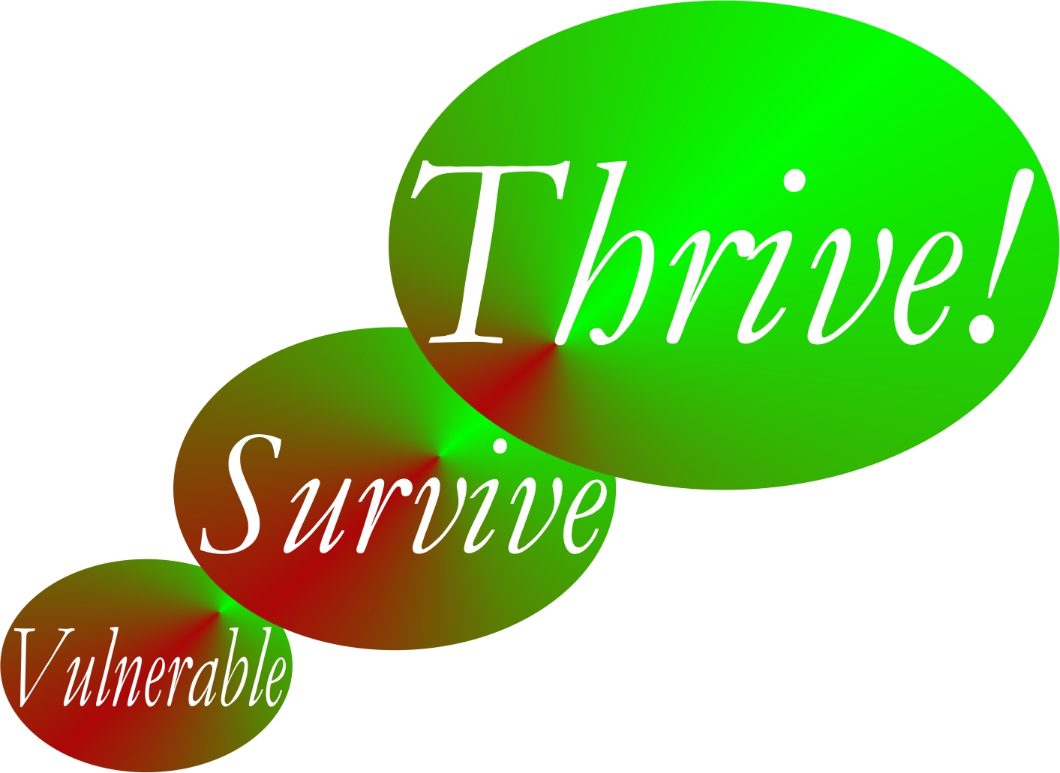

by

Gary “Chris” Christopherson

Founder, Thrive!® - Building a Thriving Future for All Forever
Founder, HealthePeople® - Building a Healthy and Thriving Future

Nelson, WI University Park, MD

Copyright © 2014 Gary Chris Christopherson

All rights reserved.
Thrive!® - People’s Guide To A Thriving Future
[For All Forever]

Complete Guide to a Thriving Future  [With Examples and Worksheets] | Complete Guide Page
Chapter 1: How to use this People’s Guide.
How to use People’s Guide to help you and your family and friends, community, country and world survive and thrive.
Chapter 2: What a thriving future will be.
What your life and our world will be in a thriving future where all survive and thrive forever.
Chapter 3: Why you and all of us must care about a thriving future.
Why you and we must care about a surviving and thriving future for you, friends and family, community, country, and world.
Chapter 4: How you and your family and friends can thrive.
How to build, achieve and sustain a surviving and thriving future for you and family and friends.
Chapter 5: How you and your community can thrive.
How to build, achieve and sustain a surviving and thriving future for you and your community.
Chapter 6: How you and your country can thrive.
How to build, achieve and sustain a surviving and thriving future for you and your country.
Chapter 7: How our world can thrive.
How to build, achieve and sustain a surviving and thriving future for our world.
Chapter 8: How the Thrive! Endeavor, you and all of us together, builds a thriving future.
How Thrive! Endeavor, you and all of us together, builds, achieves and sustains a surviving and thriving future for all forever.
Appendix: Thrive! Next Generation Toolkit.
Strategy, policy and tools for creating and sustaining large, positive change and building a thriving future.
?
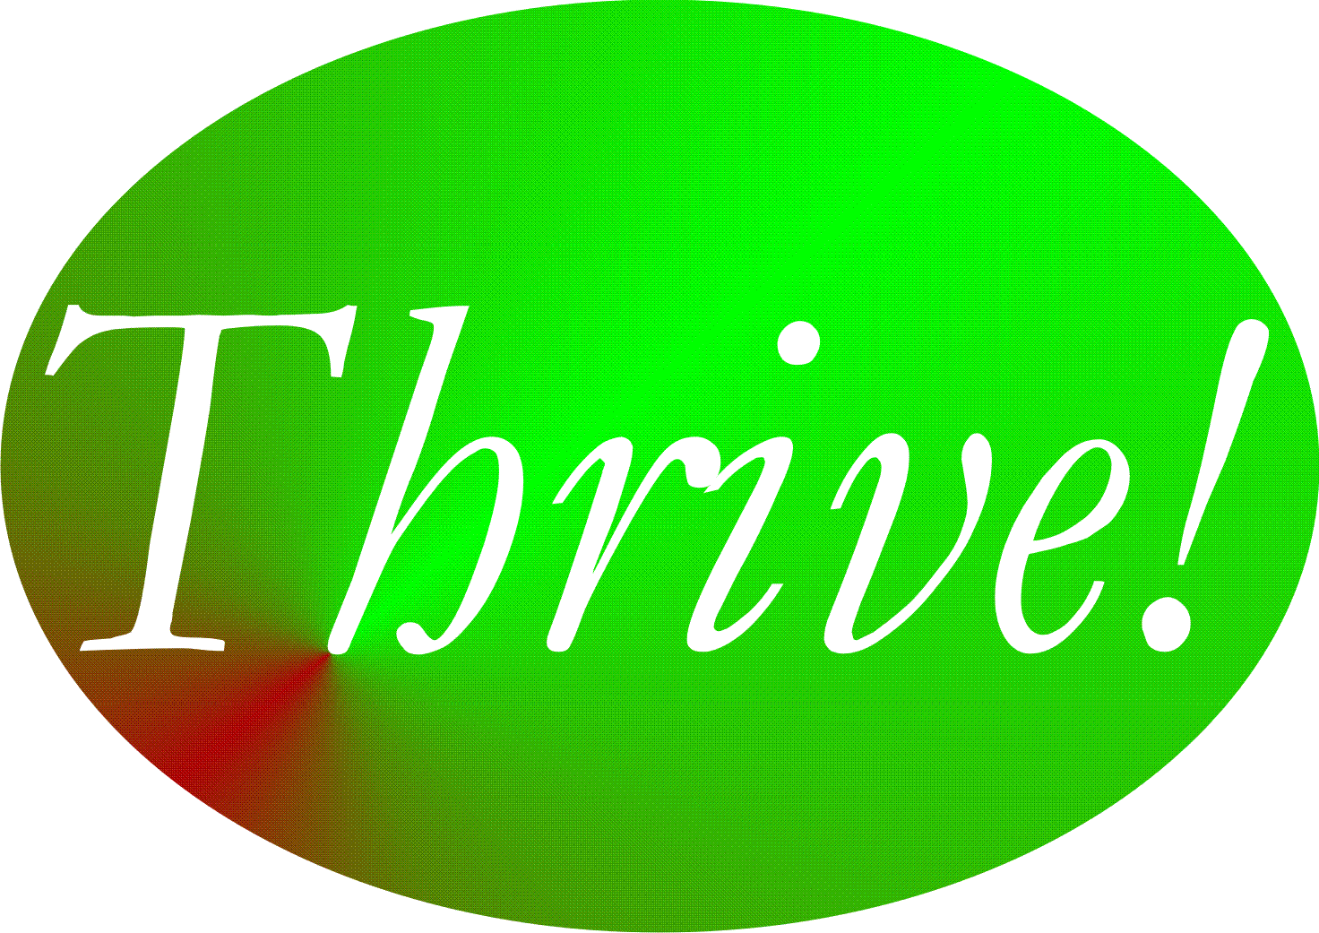

Chapter 6: How you and your country can thrive.
How to build, achieve and sustain a surviving and thriving future for you and your country.

Why you and your country can.
Thrive!
Keep in mind that we are more capable than any time in human history. We can build a thriving future by effectively and collaboratively using all available knowledge and tools, including “next generation” Thrive! strategy and tools. Next generation Thrive! is different and better than anything in human history. It is achieving a thriving future at each level. It understands that people’s behavior, including yours, makes (or breaks) a thriving future. It helps people, including you, achieve the behavior that in turn achieves a thriving future at each level and for all forever.

You and your country can have a surviving and thriving future. To get to that future, keep in mind that each country is different with a different future already beginning. Whether that future appears bad or good, each country can do better. To build a better future, the Thrive! strategy and tools has been used successfully at the personal level and on larger scales (community, country). They can work for you and the country you care about. As they have for others, this strategy and these tools can help you and your country build, achieve and sustain a surviving and thriving future.

Why you and your country must.

You and your country must have a surviving and thriving future. Each country must do better whether that future appears bad or good. Why? Even those countries that have a good future are not fully thriving, are not likely to be fully thriving in the future, and are still facing uncertainties about the long term future. You and your country want and need a surviving and thriving future because your country’s future is endangered and because of our human need to survive and desire to thrive. What drives your country and its people is our human need to survive and desire to thrive now and in a sustainable future. Further, because your country’s people (past and present) have broken some part of your country and endangered its future, you and your country’s people (present and future) must help fix what is broken and build a survivable and thriving future for your country.

Why we all must and can do it together.

To build this better future, your country’s people and leadership should be partners in this endeavor from the beginning and through each step. Success is dependent on positive leadership from the country’s people and leaders. How that leadership comes about is the subject of some debate. Some people argue for a leader driven approach where the leader creates the vision and motivation and the people join and/or follow. Some argue for bottom-up or self-organizing approaches where the people lead and the traditional leaders may or may not join and/or follow. Some argue for a collaborative approach where the traditional leaders and the people (also serving as leaders) jointly provide leadership, vision, motivation, strategy and successful execution. In general, the latter approach probably has the greater potential to create and sustain large, positive change and a surviving and thriving country.

When feasible and when your country’s national, state and local governments are a positive force, your governments should be part of the leadership and be partners in building a surviving and thriving country. However, it is not sufficient for government to be the only leader in this endeavor. Non-governmental organizations need to be leaders. Private businesses need to be leaders. Individual people need to be leaders. To be successful, this needs to be a whole country (people and leaders) endeavor.

Key to success is the strong desire by you and your country’s people to move your country from its current vulnerabilities through and beyond surviving to a sustained thriving future.

How to build, achieve, and sustain a surviving and thriving future for you and your country.

To build a surviving and thriving future for you and your country, Thrive! can be helpful to you and is laid out in the following “how-to”., The strategy, models and tools apply to countries from small size and low complexity to very large size and very high complexity.

The following “how-to”, by design, is simple but powerful. It is a relatively basic how-to providing the framework if not necessarily all the details for doing “your country” strategy.

This “your country” how-to is adapted from the Thrive! Next Generation Toolkit contained in the Appendix. More is available in Thrive! - Building a Thriving Future - a manual providing greater depth on strategy and tools and available via www.Amazon.com or free download from www.ThrivingFuture.org. The optimal approach is to use the following how-to framework and also use the strategies, models and tools in the Appendix and in Thrive! - Building a Thriving Future.

Step 1.

Step 1. Current state of you and your country. The first major step is to understand the current state of your country.

a. What is your country? Let’s first go through what is your country today. A country is defined by its geography, political boundaries, or population characteristics (e.g. racial/ethnic, gender, economics, political view, similar mission, religion, labor, profession, business).

For your country, what are its geographic boundaries and characteristics? Use Table 6.1 (end of chapter) to describe all of the following for your country. Its gender, age, racial, ethnic make-up. Lifestyle. Type of work. Financial situation. Food and drink. Housing. Protection (crime, environmental hazards). Education. Physical and mental health. Personal growth and development. Habitat (living environment, neighboring communities, part of what state, country, continent). Producing what. Climate. Sustainability.

Example. Country is has about 50 million people occupying 300 square miles on continent X. Gender mix is 51/49 female/male; age mix approximates that of the world as a whole but with slightly higher percentage under age 18; racial mix approximates that of its continent but with a slightly higher percentage of all minorities. Lifestyle mix is similar to most countries on its continent. Mix of work is similar to that of world as a whole but with a slightly larger percentage of blue collar workers, agriculture and light industry. Financial basis is similar to most countries on its continent but with slightly higher resources coming from agriculture and light industry. Food and drink is similar to most countries on its continent. A good range of housing is available for those with the means to purchase or rent; community has inadequate housing supply. Protection comes primarily from local police force, state police force and country’s military. Education is similar to most countries on its continent but with much lower college education level. Physical and mental health is similar to most countries on its continent but with slightly higher occupationally related illness. Personal growth and development is similar to most countries on its continent but with slightly more job training. Habitat consists of many rivers and lakes, widely varying terrain, and moderate deciduous tree cover; located on continent X. Country produces usual range of products and services for country on its continent, slightly higher percentage of manufactured products, wide mix of unhealthy/healthy and poorly/well educated children and a very limited range of developed recreational activities. Climate is moderate with slightly higher percentage of rainfall, slightly higher percentage of sunlight, slightly higher temperatures than other countries on its continent. Sustainability is in question due to low country revenues, under developed natural resources and changing national and international economics.

b. How well is your country? How well (surviving and thriving) is your country? Use Table 6.2 (end of chapter) to describe how well is your country. How well is your country in terms of performing well? Being well-off (financially)? Being well nourished (food and drink)? Being well housed? Being well protected (exposures, crime)? Being well educated? Being physically and mentally well? Personally growing/developing well? Living within good habitat? Not being vulnerable? Producing personal and public goods? Living within a stable, positive climate? Being sustained?

Answering “yes” to all indicates current surviving and thriving. Though the “yes” answers are good, there is still future work to make sure this continues. “No” answers are bad and mean there is current and future work to be done.

Example. Country is performing lower than average for countries on its continent with close to continent’s average mix of lifestyles for country of its size. Unemployment is 1 percentage point higher than its continent; mix of work is similar to that of its continent but with a slightly larger percentage of blue collar and of agricultural workers and light industry. Financial condition of country is not sufficiently stable and is not sufficient to support needed public services; community has slightly higher percentage of blue collar workers who are facing potential moving of jobs out of country. Food and drink is available and prices are 5% below average for its continent; country lacks sufficient sources of healthy food; low income people lack resources for healthy food and for food generally; country lacks sufficient resources to feed very poor. Housing for upper and middle income people is available and affordable; housing for low and lower middle income people is unavailable, unaffordable and inadequate. Country local police force, state police force and country military are slightly below average for its continent. Education availability and quality is slightly less than other countries on its continent; country has 10 percent less college educated. Physical and mental health is slightly below average as compared to other countries on its continent; country has slightly more occupationally related illness; private health services are substantially below average and public health services are only 75% of other countries on its continent. Personal growth and development is about the same as most countries on its continent but it has slightly more job training. Habitat is about an equal mix of pleasant and harsh and healthy and unhealthy. While country has much vulnerability, it is most vulnerable on job loss, limited income, lack of affordable and healthy foods, lack of affordable and adequate housing for poorer people, inadequate private and public health services, and low country revenues. Country produces usual range of products and services for country on its continent, slightly higher percentage of medium quality manufactured products, slightly below average percentage of healthy and well educated children and an average range of recreational activities. Climate is okay. Sustainability is in question due to potential job losses, limited income and country revenues, lower education and health, under developed natural resources and changing national and international economics.

c. What positively or negatively impacts your country? What positively or negatively impacts or is likely to impact you and your country’s surviving and thriving? Use Table 6.2 to describe all of the following impacts (positive and negative; current and future). What impacts your country’s performing well? Being well-off (financially)? Being well nourished (food and drink)? Being well housed? Being well protected (exposures, crime)? Being well educated? Being physically and mentally well? Personally growing/developing well? Living within good habitat? Not being vulnerable? Producing personal and public goods? Living within a stable, positive climate? Being sustained?

Positive impacts improve and/or sustain surviving and thriving. If they will continue, you probably can focus on other things. If they may or may not continue, your action is needed to make them continue and/or to develop other things to compensate. Bad impacts prevent or limit surviving and thriving. If they will not continue, you probably can focus on other things. If they may or may not continue, your action is needed to stop them or to avoid or minimize their impact.

Example. Country leadership negatively impacts its performing and results in lower than average performance for countries on its continent. Employers have negative impact by being reluctant to locate or expand blue collar jobs due to lower educated workforce and slightly unstable government; agriculture jobs could be a positive impact if produce more food to feed country and then export rest. Financial condition of country is not sufficiently stable and is negatively impacted by conflicts within government and with private sector; lower education and training negatively impacts blue collar workforce’s ability to compete and keep jobs from moving of jobs out of country. Food and drink is somewhat of a positive impact because it is available and prices are 5% below average for its continent; country is negatively impacted because it lacks sufficient sources of healthy food; retail and wholesale food suppliers being resistant to lowering prices and providing healthier food has a negative impact; low income people are negatively impacted because they lack resources for healthy food and for food generally; country is negatively impacted because it lacks sufficient resources to feed very poor. Housing for upper and middle income people being available and affordable has a positive impact; housing for low and lower middle income people being unavailable, unaffordable and inadequate has a negative impact; country’s low revenues and general resistance to ensuring affordable housing have a negative impact. Country local police force, state police force and country military being slightly below average for its continent has a small negative impact. Education availability and quality being slightly less than other countries on its continent has a negative impact; country being 10 percent less college educated produces a negative impact. Physical and mental health being slightly below average as compared to other countries on its continent has a negative impact; country having slightly more occupationally related illness has a negative impact; a negative impact comes from private health services being substantially below average and public health services being only 75% of other countries on its continent; country’s low revenue and lack of any public insurance negatively impact health. Personal growth and development being about the same as most countries on its continent has little impact; having slightly more job training has a positive impact. Habitat being about an equal mix of pleasant and harsh and healthy and unhealthy creates both positive and negative impacts. While country has much vulnerability, the most negative impacts come from job loss, limited income, lack of affordable and healthy foods, lack of affordable and adequate housing for poorer people, inadequate private and public health services, and low country revenues. Country producing usual range of products and services for country on its continent (little impact), slightly higher percentage of medium quality manufactured products (negative impact), slightly below average percentage of healthy and well educated children (negative impact) and an average range of recreational activities (little impact). Climate being okay has little impact near term. Sustainability being in question (due to potential job losses, limited income and country revenues, lower education and health, under developed natural resources and changing national and international economics) has a large negative impact.

d. What is near and long term future behavior of your country? How is your country likely to behave in the near and long term future. Use Table 6.2 to describe all of the following behaviors. How will your country behave with respect to performing well? Being well-off (financially). Being well nourished (food and drink)? Being well housed? Being well protected (exposures, crime)? Being well educated? Being physically and mentally well? Personally growing/developing well? Living within good habitat? Not being vulnerable? Producing personal and public goods? Living within a stable, positive climate? Being sustained?

Example. Country leadership will try to improve its performing to above the average performance for countries on its continent. Employers will continue to refuse to locate or expand blue collar jobs due to lower educated workforce and slightly unstable government; agriculture producers inside and outside country will try to increase agriculture production and jobs to produce more food to feed country and then export rest. Government and private leaders will continue conflict that results in poor financial and unstable condition of country; governments continue low investment in education an training but private sector may offer some job training to increase blue collar workforce’s ability to compete and keep jobs from moving of jobs out of country. Country will work with food and drink producers, wholesalers and retailers to increase sources of healthy food; retail and wholesale food suppliers may try lowering prices and providing healthier food; low income people will struggle to survive because they lack resources for healthy food and for food generally; country may try to find way to get sufficient resources to feed very poor. Bankers and builders will continue supporting housing for upper and middle income people that is available and affordable; government, bankers and builders may continue to not support housing for low and lower middle income people being available, affordable and adequate; country will try to find way to increase low revenues and be more open to ensuring affordable housing. Country will continue to support local police force, state police force and country military to be slightly below average for its continent. Governments at all levels will try to determine how to improve education availability and quality above other countries on its continent; country will try to improve college availability and affordability and to recruit college educated. Country and private and public sector health services will explore how to improve physical and mental health to be above average as compared to other countries on its continent; country and employers will consider efforts to reduce occupationally related illness; private health services may seek government and sources outside country to improve services; country and local governments will try to figure out how to increase public revenues and improve public health services above 75% of other countries on its continent; country will try to figure out how to increase revenue and remove lack of any public insurance. Country will likely continue current levels of personal growth and development being about the same as most countries on its continent; employers explore more job training. Country may do little about habitat though being about an equal mix of pleasant and harsh and healthy and unhealthy has both positive and negative impacts. Because the country has much vulnerability as noted earlier, the country will explore how to reduce vulnerability but will need to increase revenues. Country will likely continue producing usual range of products and services for country on its continent, slightly higher percentage of medium quality manufactured products, slightly below average percentage of healthy and well educated children and an average range of recreational activities. Country will be less likely to act on climate being it is okay now and has little impact near term. Because sustainability is in question (due to potential job losses, limited income and country revenues, lower education and health, under developed natural resources and changing national and international economics), country will explore how best to survive and is unlikely to explore how best to thrive.

e. Want more on your country’s future and behavior? At this point, you have a basic baseline with which to measure progress for your country. Your country may have enough good information to move to Step 2 and to develop strategy for you and your country. If your country wants more information before moving to strategy, your country may want to use more of the tools and models already mentioned and the Thrive! Next Generation Toolkit (Appendix). This is encouraged and may be necessary for very large, complex countries.

Using the full Thrive! Next Generation Toolkit (Appendix) is recommended because it includes more strategy, policy and tools for creating and sustaining large, positive change and building a surviving and thriving future. Using the manual Thrive! - Building a Thriving Future is recommended because it provides even greater depth on strategy and tools. It is available via www.Amazon.com or free download from www.ThrivingFuture.org.

Step 2.

Step 2. Strategy to achieve you and your country’s surviving and thriving future. The next major step is to develop the strategy that will help you and your country build and achieve a surviving and thriving future.

a. What will your country be in the future? What will be your likely future country? Use Table 6.3 (end of chapter) to describe the likely future. If there are any changes to your country that are desired or likely, take them into account. What will be its characteristics? Type of work/how people live. Financial situation. Food and drink. Housing. Protection (crime, environmental hazards). Education. Physical and mental health. Personal growth and development. Habitat (living environment, neighboring communities, part of what state, country, continent). Producing what. Climate. Sustainability.

Example. Country will change very little. It will still be about 50 million people occupying 300 square miles on continent X. Gender mix will continue at about 51/49 female/male; age mix will approximate that of the world as a whole but with slightly higher percentage under age 21; racial mix will approximate that of its continent but with a slightly higher percentage of all minorities. Lifestyle mix will be similar to most countries on its continent. Mix of work will be similar to that of world as a whole but with a smaller percentage of blue collar workers, a higher percentage of agriculture workers and a smaller percentage of light industry. Financial basis will weaker and be lower than most countries on its continent but with substantially higher percentage of resources coming from agriculture. Food and drink will be similar to most countries on its continent. A good range of housing will be available for those with the means to purchase or rent; community will have inadequate housing supply. Protection will come primarily from local police force, state police force and country’s military. Education will be lower than most countries on its continent and with much lower college education level. Physical and mental health will be slightly lower than most countries on its continent and it no longer has higher occupationally related illness. Personal growth and development will be similar to most countries on its continent but with slightly more job training. Habitat will consist of many rivers and lakes, widely varying terrain, and moderate deciduous tree cover; located on continent X. Country will produce usual range of products and services for country on its continent, the same or lower higher percentage of manufactured products, wide mix of unhealthy/healthy and poorly/well educated children and a very limited range of developed recreational activities. Climate will be moderate in the near term with slightly higher percentage of rainfall, slightly higher percentage of sunlight, slightly higher temperatures than other countries on its continent. Sustainability will be in question due to low country revenues, under developed natural resources and changing national and international economics.

b. How well should your country be in the near and long term future? How well should your country as a whole be in the future? Overall, it should be surviving and thriving. With this as a guide, you and your country choose the surviving and thriving future your community wants to build and achieve. The “Thrive! strategy” will help you accomplish that.

Use Table 6.4 (end of chapter) to describe how well your country should be. From you and your country’s view and to be surviving and thriving, indicate to what extent your country should be performing well. Be well-off (financially). Be well nourished (food and drink). Be well housed. Be well protected (exposures, crime). Be well educated. Be physically and mentally well. Be personally growing/developing well. Be living within good habitat. Not be vulnerable. Be producing personal and public goods. Be living within a stable, positive climate. Be sustained. Again, your country should be surviving and thriving.

Example. Country should perform better than countries on its continent with close to continent’s average mix of lifestyles for country of its size. Unemployment should be lower than its continent; mix of work should be similar to that of its continent but with a larger percentage of blue collar and of agricultural workers and light industry. Financial condition of country should be stable and sufficient to support needed public services; community has slightly higher percentage of blue collar workers who should not face potential moving of jobs out of country. Food and drink should be available and prices should be 10% below average for its continent; country should have sufficient sources of healthy food; low income people should have resources for healthy food and for food generally; country should have sufficient resources to feed very poor. Housing for upper and middle income people should be available and affordable; housing for low and lower middle income people should be available, affordable and adequate. Country local police force, state police force and country military should be best for its continent. Education availability and quality should be best on its continent; country should have 10 percent more college educated than its continent. Physical and mental health should be best compared to other countries on its continent; country should have substantially less occupationally related illness; private and public health services should be best on its continent. Personal growth and development should be better than countries on its continent and have substantially more job training. Habitat should have the best mix of pleasant and harsh and healthy and unhealthy on its continent. While country has had much vulnerability, it should no longer be vulnerable on job loss, limited income, lack of affordable and healthy foods, lack of affordable and adequate housing for poorer people, inadequate private and public health services, and low country revenues. Compared to its continent, country should produce an optimal range of products and services for its continent, a substantially higher percentage of high quality manufactured products, the best percentage of healthy and well educated children and a wide range of recreational activities. Climate should be very good and stay that way. Sustainability should be ensured and no longer be in question due to potential job losses, limited income and country revenues, lower education and health, under developed natural resources and changing national and international economics.

c. What has to change externally and internally to achieve your country’s thriving future? What has to change externally (outside your country) and internally (within your country) to progress from your country’s current status to achieve your desired surviving and thriving status? In Step 1, you identified what positively and negatively impacts or is likely to impact your country. Update those, including any changes to your future country.

Given those, what has to change externally and internally to achieve a surviving and thriving future? Use Table 6.4 to describe all that has to change for the following. To achieve performing well? Being well-off (financially)? Being well nourished (food and drink)? Being well housed? Being well protected (exposures, crime)? Being well educated? Being physically and mentally well? Personally growing/developing well? Living within good habitat? Not being vulnerable? Producing personal and public goods? Living within a stable, positive climate? Being sustained?

Good changes improve and/or sustain surviving and thriving. Bad changes prevent and/or limit surviving and thriving.

Example. Internally, country should have a better, more collaborative government with a collaborative partnership with the private sector committed to perform better than countries on its continent. Internally, more business, agriculture and light industry should stay in country with more employment for blue collar and agriculture workers. Externally, more business, agriculture and light industry should move into country with more employment for blue collar and agriculture workers. Internally, government and private sector should collaborate and ensure financial condition is stable and sufficient to support needed public services; employers should be committed to blue collar workers and not moving their jobs out of country; country and employers should have expanded job training. Internally, food and drink producers, wholesalers and retailers should ensure food and drink is available and 10% below average cost for its continent; country and food industry should ensure sufficient sources of healthy food; country should ensure low income people have resources for healthy food and for food generally; country should ensure sufficient resources to feed very poor. Internally, banks and housing industry should ensure housing for upper and middle income people is available and affordable; government, bankers and builders should ensure housing for low and lower middle income people is available, affordable and adequate. Internally, country and its local police force, state police force and country military should ensure it is best of its continent, including adequate resourcing. Internally, country and its education people should ensure education availability and quality is best on its continent and should ensure country has 10 percent more college educated than its continent. Internally, country and its private and public health services should ensure physical and mental health is best compared to other countries on its continent; country and employers should ensure workers have substantially less occupationally related illness; country and private and public health services should ensure services are best on its continent; country should ensure every person without private insurance has financial access to needed health services; country and its people should ensure each person is improving personal and family health. Internally, country and its people should ensure personal growth and development is better than countries on its continent; country and employers should ensure substantially more job training. Internally, country and its people should ensure habitat has the best mix of pleasant and harsh and healthy and unhealthy on its continent. Externally, country and its neighboring countries should jointly ensure habitat has the best mix of pleasant and harsh and healthy and unhealthy. Internally, while country has had much vulnerability, country and its people should ensure it is no longer vulnerable on job loss, limited income, lack of affordable and healthy foods, lack of affordable and adequate housing for poorer people, inadequate private and public health services, and low country revenues. Internally and compared to its continent, country and its people should ensure it produces an optimal range of products and services for its continent, a substantially higher percentage of high quality manufactured products, the best percentage of healthy and well educated children on its continent and a wide range of recreational activities. Externally, country should join with international community to ensure climate is very good and stays that way. Internally, country and its people should ensure sustainability and that there is no longer job losses, limited income and country revenues, lower education and health, under developed natural resources and no negative impact from changing national and international economics. Externally, country should join with neighboring countries and international community to ensure no negative impact from changing national and international economics.

d. What actions by your country are needed to achieve its thriving future? What internal actions (by you and your country) and external actions (by others) are needed to bring about the needed external and internal changes (identified in “c”) that improve your country’s current status enough to achieve the desired surviving and thriving status? [Figure 6.1]

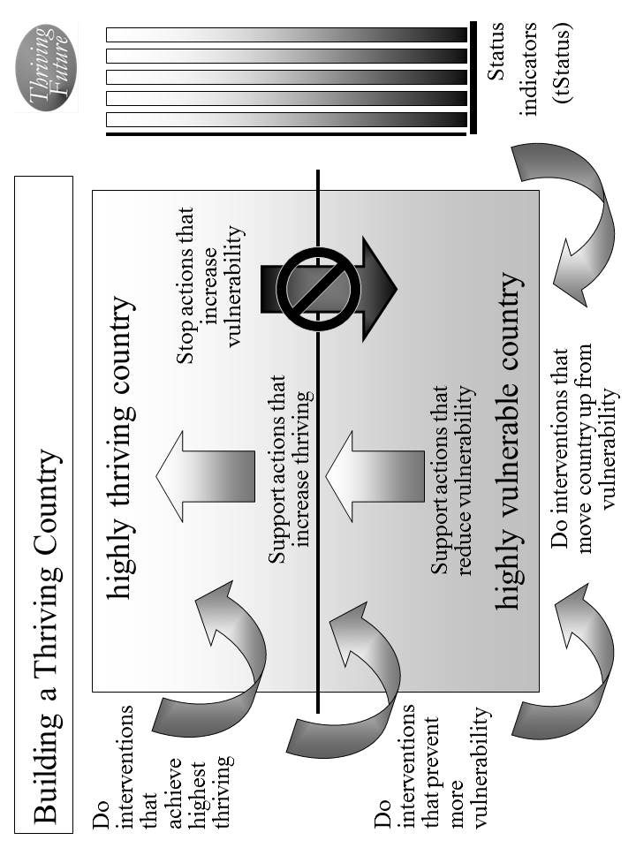
Figure 6.1. Building a Thriving Country.

External actions by others. There are very important external actions that are needed to support the Thrive! strategy. You already identified what has to change externally to achieve your country’s surviving and thriving future. What external actions by others will bring about the needed changes?

Use Table 6.4 to describe all the external actions to be taken.

Identify external actions by others that support good changes that will help improve and/or sustain surviving and thriving. If good changes are likely to occur, together with others support them. If good changes are not likely to occur, together with others support them and develop other good changes to compensate. [Use Table 6.4]

Identify external actions by others that stop bad changes that prevent or limit surviving and thriving. If bad changes are not likely to occur, together with others ensure they do not. If bad changes are likely to occur, together with others change them, stop them or avoid/reduce their impact.

Example. More business, agriculture and light industry move into country with more employment for blue collar and agriculture workers. Neighboring countries jointly help ensure habitat has the best mix of pleasant and harsh and healthy and unhealthy. International community ensures climate is very good and stays that way. Neighboring countries and international community help ensure no negative impact from changing national and international economics.

Internal actions by your country. There are very important internal actions by you and your country that support the Thrive! strategy. Individual country members and your country as a whole should support your country’s strategy to ensure your country and each country member are performing well. Being well-off (financially). Being well nourished (food and drink). Being well housed. Being well protected (exposures, crime). Being well educated. Being physically and mentally well. Personally growing/developing well. Living within good habitat. Not being vulnerable. Producing personal and public goods. Living within a stable, positive climate. Being sustained.

Use Table 6.4 to describe all the internal actions to be taken.

Identify internal actions by your country that support good changes that will help improve and/or sustain surviving and thriving. If good changes are likely to occur, support them. If good changes are not likely to occur, support them and develop other good changes to compensate.

Identify internal actions by your country that stop bad changes that prevent or limit surviving and thriving. If bad changes are not likely to occur, ensure they do not. If bad changes are likely to occur, change them, stop them or avoid/reduce their impact.

Example. Country builds and sustains a better, more collaborative government with a collaborative partnership with the private sector committed to perform better than countries on its continent. With small incentives added by government, more business, agriculture and light industry stay in country with more employment for blue collar and agriculture workers. With small incentives added by government, more business, agriculture and light industry move into country with more employment for blue collar and agriculture workers. Government and private sector collaborate and ensure financial condition is stable and sufficient to support needed public services; employers commit to blue collar workers and to not moving their jobs out of country; country and employers expand job training. Food and drink producers, wholesalers and retailers ensure food and drink is available and 10% below average cost for its continent; country and food industry ensure sufficient sources of healthy food; country helps ensure low income people have resources for healthy food and for food generally; country ensures sufficient resources to feed very poor. Banks and housing industry ensure housing for upper and middle income people is available and affordable; government, bankers and builders ensure housing for low and lower middle income people is available, affordable and adequate. Country and its local police force, state police force and country military ensure it is best of its continent, including adequate resourcing. Country and its education people ensure education availability and quality is best on its continent and ensure country has 10 percent more college educated than its continent. Country and its private and public health services ensure physical and mental health is best compared to other countries on its continent; country and employers ensure workers have substantially less occupationally related illness; country and private and public health services ensure services are best on its continent; country ensures every person without private insurance has financial access to needed health services; country and its people ensure each person is improving personal and family health. Country and its people ensure personal growth and development is better than countries on its continent; country and employers ensure substantially more job training. Country and its people ensure habitat has the best mix of pleasant and harsh and healthy and unhealthy on its continent. Country joins with its neighboring countries to jointly ensure habitat has the best mix of pleasant and harsh and healthy and unhealthy. While country has had much vulnerability, country and its people ensure it is no longer vulnerable on job loss, limited income, lack of affordable and healthy foods, lack of affordable and adequate housing for poorer people, inadequate private and public health services, and low country revenues. Compared to its continent, country and its people ensure it produces an optimal range of products and services for its continent, a substantially higher percentage of high quality manufactured products, the best percentage of healthy and well educated children on its continent and a wide range of recreational activities. Country joins with international community to ensure climate is very good and stays that way. Country and its people ensure sustainability and that there is no longer job losses, limited income and country revenues, lower education and health, under developed natural resources and negative impact from changing national and international economics. Country joins with neighboring countries and international community to ensure no negative impact from changing national and international economics.

Overall Thrive! strategy and actions. Your country’s overall Thrive! strategy and actions need to be documented and agreed to by your country. This will be your country’s Thrive! Strategy and Action Plan. Different members of your country will take on different responsibilities. For each action, designate who of your country will do what to/with whom, where, when, and with what result. [See example below.] Use Table 6.4 to document these actions and responsibilities. [See example table below.] Make sure your country has all the actions that are needed to build, achieve and sustain a surviving and thriving country.

As the strategy is executed, your country’s strategy, actions and results should be updated in your Thrive! Strategy and Action Plan.

Periodically, you and your country should do an evaluation - assessing your country’s strategies/actions near and long term impact on near and long term surviving and thriving. When a) your country’s strategies and actions are not building and sustaining a thriving future and/or b) there are changes in the external world and in your country, you and your country should adjust your overall Thrive! strategy and actions.

The key is to successfully execute your country’s Thrive! Strategy and Action Plan and to build a near and long term surviving and thriving future. Each and all must successfully carry out the assigned action. That is, each/all must successfully do what is required to/with whoever is required, where required, when required, and with what needed/desired result. A Thrive! Strategy and Action Plan is only as good as its successful execution and successful achievement of the desired outcome - a surviving and thriving future.

Example of a country surviving and somewhat thriving. [Who will do what to/with whom, where, when, and with what result?] See Example Thrive! Strategy and Action Plan in list and table below. With these actions, country would be surviving and doing better but would not yet have achieved full thriving.
External Actions: Twenty-five percent more business, agriculture and light industry move into country with more employment for blue collar and agriculture workers within 2 years. Neighboring countries agree within 1 year and jointly help ensure habitat has the best mix of pleasant and harsh and healthy and unhealthy with phased plan over next 5 years. International community comes to agreement within 2 years and ensures climate is very good and stays that way for centuries to come. Neighboring countries and international community come to agreement within 1 year and help ensure no negative impact from changing national and international economics for at least next 10 years.
Internal Actions: Within 1 year, country builds and sustains a better, more collaborative government with a collaborative partnership with the private sector committed to perform better than countries on its continent. With small incentives added by government, 95% of business, agriculture and light industry stay in country with more employment for blue collar and agriculture workers. With small incentives added by government, 25 percent more business, agriculture and light industry move into country within 2 years with more employment for blue collar and agriculture workers. Government and private sector collaborate and come to agreement this year and ensure financial condition is stable and sufficient to support needed public services for at least next 5 years; employers commit to blue collar workers and not moving their jobs out of country for at least next 5 years; country and employers expand job training by 50% within 1 year with 50/50 funding. Food and drink producers, wholesalers and retailers ensure food and drink is available and 10% below average cost for its continent for at least next 3 years; country and food industry agree to and ensure sufficient sources of healthy food for at least next 3 years; country comes to agreement, provides funding and helps ensure low income people have resources for healthy food and for food generally for at least next 5 years; country comes to agreement, provides funding and ensures sufficient resources to feed very poor for at least next 5 years. Banks and housing industry continue to ensure housing for upper and middle income people is available and affordable for at least next 5 years; government, bankers and builders come to agreement, government provides incentive funding and all ensure housing for low and lower middle income people is available, affordable and adequate within 5 years. Country and its local police force, state police force and country military ensure it is best of its continent, including strong management and adequate resourcing for at least next 5 years. Country and its education people come to agreement within 1 year; government provides funding; and all ensure education availability and quality is best on its continent and ensure country has 10 percent more college educated than its continent for at least next 5 years. Country and its private and public health services agree and within 2 years ensure physical and mental health is best compared to other countries on its continent; country and employers agree within 1 year and ensure workers have substantially less occupationally related illness; country and private and public health services agree within 1 year and ensure services are best on its continent within 2 years; country agrees within 1 year, provides funding for at least 5 years, and ensures every person without private insurance has financial access to needed health services for at least the next 5 years; country and its people begin collaborative effort this year and ensure each person is improving personal and family health starting within 2 years. Country and its people begin collaborative effort this year and ensure personal growth and development is better than countries on its continent within 2 years; country and employers agree within 1 year and agree to 50/50 funding ensure substantially more job training within 1 year. Country and its people develop collaborative effort and strategy and, within 5 years, ensure habitat has the best mix of pleasant and harsh and healthy and unhealthy on its continent. Starting immediately, country joins with neighboring countries, agree within 1 year, and jointly help ensure habitat has the best mix of pleasant and harsh and healthy and unhealthy with phased plan over next 5 years. While country has had much vulnerability, country and its people collaborate, develop strategy and, within 1 year start to ensure it is no longer vulnerable on job loss, limited income, lack of affordable and healthy foods, lack of affordable and adequate housing for poorer people, inadequate private and public health services, and low country revenues. Within 5 years and compared to its continent, country and its people work together to ensure it produces an optimal range of products and services for its continent, a substantially higher percentage of high quality manufactured products, the best percentage of healthy and well educated children on its continent and a wide range of recreational activities. Starting immediately, country joins with international community, comes to agreement within 2 years and ensures climate is very good and stays that way for centuries to come. Country and its people collaborate, develop strategy and, within 1 year work to ensure sustainability and that there is no longer job losses, limited income and country revenues, lower education and health, under developed natural resources and negative impact from changing national and international economics for at least next 10 years. Starting immediately, country joins with neighboring countries and international community, comes to agreement within 1 year and helps ensure no negative impact from changing national and international economics for at least the next 10 years.

But, we want a thriving future for you and your country. To build, achieve and sustain a surviving and thriving future, the Thrive! Strategy and Action Plan should be more like the following example:

Example of you and your country surviving and thriving. [Who will do what to/with whom, where, when, and with what result?] Starting immediately for you and your country, people, business/industry, private organizations (local, country), governments (local, country) and international organizations build, achieve, and sustain a surviving and thriving future for you and your country, including:
- Performing well. Starting immediately for you and your country, people, business/industry, private organizations (local, country), governments (local, country) and international organizations act to ensure, within the next 20 years, a) all (who are able and not appropriately retired) can work and earn a living income sufficient to survive and thrive and b) all have sufficient resources for and are living, recreating, learning so that they are surviving and thriving to maximum extent feasible.
- Being well-off (financially). Starting immediately for you and your country, people, business/industry, private organizations (local, country), governments (local, country) and international organizations act to ensure, within the next 20 years, a) all have sufficient income/resources to survive and thrive and b) all governments have sufficient resources to provide needed (supporting surviving) and desired (supporting thriving) public programs and policies.
- Being well nourished (food and drink). Starting immediately for you and your country, people, business/industry, private organizations (local, country), governments (local, country) and international organizations act to ensure, within the next 20 years, that all have access to, be able to afford and consume healthy foods enough to survive and thrive.
- Being well housed. Starting immediately for you and your country, people, business/industry, private organizations (local, country), governments (local, country) and international organizations act to ensure, within the next 20 years, all have access to, be able to afford and live in adequate and preferably high performing housing that supports surviving and thriving.
- Being well protected (exposures, crime). Starting immediately for you and your country, people, business/industry, private organizations (local, country), governments (local, country) and international organizations act to ensure, within the next 20 years, a) environmental exposures in home, workplace and elsewhere are minimized so as to not prevent surviving and thriving and b) crimes are minimized to the extent feasible in terms of frequency and impact so as to not prevent surviving and thriving.
- Being well educated. Starting immediately for you and your country, people, business/industry, private organizations (local, country), governments (local, country) and international organizations act to ensure, within the next 20 years, all people are educated to the full extent of their abilities, needs and desires and to support their surviving and thriving.
- Being physically and mentally well. Starting immediately for you and your country, people, business/industry, private organizations (local, country), governments (local, country) and international organizations act to ensure, within the next 20 years, a) all receive the optimal health support to ensure, within the next 20 years, surviving and thriving and b) physical and mental health is optimized to best ensure surviving and thriving.
- Personally growing/developing well. Starting immediately for you and your country, people, business/industry, private organizations (local, country), governments (local, country) and international organizations act to ensure, within the next 20 years, all are personally growing and developing to best ensure surviving and thriving.
- Living within good habitat. Starting immediately for you and your country, people, business/industry, private organizations (local, country), governments (local, country) and international organizations act to ensure, within the next 20 years, a) all have access to habitat that best supports their surviving and thriving and b) your country has the optimal mix, quantity and quality of habitat to best support its inhabitants’ surviving and thriving.
- Not being vulnerable. Starting immediately for you and your country, people, business/industry, private organizations (local, country), governments (local, country) and international organizations act to ensure, within the next 20 years, your country and all of its people, if vulnerable, are vulnerable only to the minimum extent feasible.
- Producing personal and public goods. Starting immediately for you and your country, people, business/industry, private organizations (local, country), governments (local, country) and international organizations act to ensure, within the next 20 years, your country produces personal and public goods (including personal income/resources, housing, food and drink, energy, education, health, protection, personal growth and development, and habitat) so as to support surviving and thriving for all persons and for our world overall.
- Living within a stable, positive climate. Starting immediately for you and your country, people, business/industry, private organizations (local, country), governments (local, country) and international organizations act to ensure, within the next 10 years, all behave so as to avoid negative impacts and support positive impacts so as to help ensure a stable, positive climate.
- Being sustained. Starting immediately for you and your country, people, business/industry, private organizations (local, country), governments (local, country) and international organizations act to ensure, within the next 5 years, all behave so as to ensure the sustainability of your country and its people.

Thrive! Strategy and Action Plan (Example of surviving and somewhat thriving).
Thriving and Surviving | How well (surviving/ thriving) should your country be in near/long term future? | External/internal changes needed to achieve surviving and thriving future | Actions by your country and others - Who will do what to/with whom, where, when, and with what result?
Performing (live/work/ play) well? | Country should perform better than countries on its continent with close to continent’s average mix of lifestyles for country of its size. Unemployment should be lower than its continent; mix of work should be similar to that of its continent but with a larger percentage of blue collar and of agricultural workers and light industry. | External: Externally, more business, agriculture and light industry should move into country with more employment for blue collar and agriculture workers. | External by others: Twenty-five percent more business, agriculture and light industry move into country with more employment for blue collar and agriculture workers within 2 years.
Performing (live/work/ play) well? |  |  | Internal by your country:
Performing (live/work/ play) well? |  | Internal: Internally, country should have a better, more collaborative government with a collaborative partnership with the private sector committed to perform better than countries on its continent. Internally, more business, agriculture and light industry should stay in country with more employment for blue collar and agriculture workers. | Internal by your country: Within 1 year, country builds and sustains a better, more collaborative government with a collaborative partnership with the private sector committed to perform better than countries on its continent. With small incentives added by government, 95% of business, agriculture and light industry stay in country with more employment for blue collar and agriculture workers. With small incentives added by government, 25 percent more business, agriculture and light industry move into country within 2 years with more employment for blue collar and agriculture workers.
Well-off? | Financial condition of country should be stable and sufficient to support needed public services; community has slightly higher percentage of blue collar workers who should not face potential moving of jobs out of country. | External: | External by others:
Well-off? |  | External: | Internal by your country:
Well-off? |  | Internal: Internally, government and private sector should collaborate and ensure financial condition is stable and sufficient to support needed public services; employers should be committed to blue collar workers and not moving their jobs out of country; country and employers should have expanded job training. | Internal by your country: Government and private sector collaborate and come to agreement this year and ensure financial condition is stable and sufficient to support needed public services for at least next 5 years; employers commit to blue collar workers and not moving their jobs out of country for at least next 5 years; country and employers expand job training by 50% within 1 year with 50/50 funding.
Well nourished? | Food and drink should be available and prices should be 10% below average for its continent; country should have sufficient sources of healthy food; low income people should have resources for healthy food and for food generally; country should have sufficient resources to feed very poor. | External: | External by others:
Well nourished? |  | External: | Internal by your country:
Well nourished? |  | Internal: Internally, food and drink producers, wholesalers and retailers should ensure food and drink is available and 10% below average cost for its continent; country and food industry should ensure sufficient sources of healthy food; country should ensure low income people have resources for healthy food and for food generally; country should ensure sufficient resources to feed very poor. | Internal by your country: Food and drink producers, wholesalers and retailers ensure food and drink is available and 10% below average cost for its continent for at least next 3 years; country and food industry agree to and ensure sufficient sources of healthy food for at least next 3 years; country comes to agreement, provides funding and helps ensure low income people have resources for healthy food and for food generally for at least next 5 years; country comes to agreement, provides funding and ensures sufficient resources to feed very poor for at least next 5 years.
Well housed | Housing for upper and middle income people should be available and affordable; housing for low and lower middle income people should be available, affordable and adequate. | External: | External by others:
Well housed |  | External: | Internal by your country:
Well housed |  | Internal: Internally, banks and housing industry should ensure housing for upper and middle income people is available and affordable; government, bankers and builders should ensure housing for low and lower middle income people is available, affordable and adequate. | Internal by your country: Banks and housing industry continue to ensure housing for upper and middle income people is available and affordable for at least next 5 years; government, bankers and builders come to agreement, government provides incentive funding and all ensure housing for low and lower middle income people is available, affordable and adequate within 5 years.
Well protected? | Country local police force, state police force and country military should be best for its continent. | External: | External by others:
Well protected? |  | External: | Internal by your country:
Well protected? |  | Internal: Internally, country and its local police force, state police force and country military should ensure it is best of its continent, including adequate resourcing. | Internal by your country: Country and its local police force, state police force and country military ensure it is best of its continent, including strong management and adequate resourcing for at least next 5 years.
Well educated? | Education availability and quality should be best on its continent; country should have 10 percent more college educated than its continent. | External: | External by others:
Well educated? |  | External: | Internal by your country:
Well educated? |  | Internal: Internally, country and its education people should ensure education availability and quality is best on its continent and should ensure country has 10 percent more college educated than its continent. | Internal by your country: Country and its education people come to agreement within 1 year; government provides funding; and all ensure education availability and quality is best on its continent and ensure country has 10 percent more college educated than its continent for at least next 5 years.
Physically/ mentally well? | Physical and mental health should be best compared to other countries on its continent; country should have substantially less occupationally related illness; private and public health services should be best on its continent. | External: | External by others:
Physically/ mentally well? |  | External: | Internal by your country:
Physically/ mentally well? |  | Internal: Internally, country and its private and public health services should ensure physical and mental health is best compared to other countries on its continent; country and employers should ensure workers have substantially less occupationally related illness; country and private and public health services should ensure services are best on its continent; country should ensure every person without private insurance has financial access to needed health services; country and its people should ensure each person is improving personal and family health. | Internal by your country: Country and its private and public health services agree and within 2 years ensure physical and mental health is best compared to other countries on its continent; country and employers agree within 1 year and ensure workers have substantially less occupationally related illness; country and private and public health services agree within 1 year and ensure services are best on its continent within 2 years; country agrees within 1 year, provides funding for at least 5 years, and ensures every person without private insurance has financial access to needed health services for at least the next 5 years; country and its people begin collaborative effort this year and ensure each person is improving personal and family health starting within 2 years.
Growing/ developing well? | Personal growth and development should be better than countries on its continent and have substantially more job training. | External: | External by others:
Growing/ developing well? |  | External: | Internal by your country:
Growing/ developing well? |  | Internal: Internally, country and its people should ensure personal growth and development is better than countries on its continent; country and employers should ensure substantially more job training. | Internal by your country: Country and its people begin collaborative effort this year and ensure personal growth and development is better than countries on its continent within 2 years; country and employers agree within 1 year and agree to 50/50 funding ensure substantially more job training within 1 year.
Living in good habitat? | Habitat should have the best mix of pleasant and harsh and healthy and unhealthy on its continent. | External: Externally, country and its neighboring countries should jointly ensure habitat has the best mix of pleasant and harsh and healthy and unhealthy. | External by others: Neighboring countries agree within 1 year and jointly help ensure habitat has the best mix of pleasant and harsh and healthy and unhealthy with phased plan over next 5 years.
Living in good habitat? |  |  | Internal by your country: Starting immediately, country joins with neighboring countries, agree within 1 year, and jointly help ensure habitat has the best mix of pleasant and harsh and healthy and unhealthy with phased plan over next 5 years.
Living in good habitat? |  | Internal: Internally, country and its people should ensure habitat has the best mix of pleasant and harsh and healthy and unhealthy on its continent. | Internal by your country: Country and its people develop collaborative effort and strategy and, within 5 years, ensure habitat has the best mix of pleasant and harsh and healthy and unhealthy on its continent.
Not vulnerable? | While country has had much vulnerability, it should no longer be vulnerable on job loss, limited income, lack of affordable and healthy foods, lack of affordable and adequate housing for poorer people, inadequate private and public health services, and low country revenues. | External: | External by others:
Not vulnerable? |  | External: | Internal by your country:
Not vulnerable? |  | Internal: Internally, while country has had much vulnerability, country and its people should ensure it is no longer vulnerable on job loss, limited income, lack of affordable and healthy foods, lack of affordable and adequate housing for poorer people, inadequate private and public health services, and low country revenues. | Internal by your country: While country has had much vulnerability, country and its people collaborate, develop strategy and, within 1 year start to ensure it is no longer vulnerable on job loss, limited income, lack of affordable and healthy foods, lack of affordable and adequate housing for poorer people, inadequate private and public health services, and low country revenues.
Producing personal/ public goods? | Compared to its continent, country should produce an optimal range of products and services for its continent, a substantially higher percentage of high quality manufactured products, the best percentage of healthy and well educated children and a wide range of recreational activities. | External: | External by others:
Producing personal/ public goods? |  | External: | Internal by your country:
Producing personal/ public goods? |  | Internal: Internally and compared to its continent, country and its people should ensure it produces an optimal range of products and services for its continent, a substantially higher percentage of high quality manufactured products, the best percentage of healthy and well educated children and a wide range of recreational activities. | Internal by your country: Within 5 years and compared to its continent, country and its people work together to ensure it produces an optimal range of products and services for its continent, a substantially higher percentage of high quality manufactured products, the best percentage of healthy and well educated children on its continent and a wide range of recreational activities.
Stable, positive climate? | Climate should be very good and stay that way. | External: Externally, country should join with international community to ensure climate is very good and stays that way. | External by others: International community comes to agreement within 2 years and ensures climate is very good and stays that way for centuries to come.
Stable, positive climate? | Climate should be very good and stay that way. |  | Internal by your country: Starting immediately, country joins with international community, comes to agreement within 2 years and ensures climate is very good and stays that way for centuries to come.
Stable, positive climate? | Climate should be very good and stay that way. | Internal: | Internal by your country:
Sustainable? | Sustainability should be ensured and no longer be in question due to potential job losses, limited income and country revenues, lower education and health, under developed natural resources and changing national and international economics. | External: Externally, country should join with neighboring countries and international community to ensure no negative impact from changing national and international economics. | External by others: Neighboring countries and international community come to agreement within 1 year and help ensure no negative impact from changing national and international economics for at least next 10 years.
Sustainable? |  |  | Internal by your country: Starting immediately, country joins with neighboring countries and international community, comes to agreement within 1 year and helps ensure no negative impact from changing national and international economics for at least the next 10 years.
Sustainable? |  | Internal: Internally, country and its people should ensure sustainability and that there is no longer job losses, limited income and country revenues, lower education and health, under developed natural resources and no negative impact from changing national and international economics. | Internal by your country: Country and its people collaborate, develop strategy and, within 1 year work to ensure sustainability and that there is no longer job losses, limited income and country revenues, lower education and health, under developed natural resources and negative impact from changing national and international economics for at least next 10 years.
Table 6.4. Thrive! Strategy and Action Plan. How well (surviving/thriving) should your country be in near/long term future? What external/internal changes are needed to achieve your country’s thriving future? To make this happen, what external/internal actions are needed?

Country Characteristics | What is your country today?
Geographic boundaries
Gender make-up
Age make-up
Racial make-up
Ethnic make-up
Lifestyle
Type of work
Financial situation
Food/drink
Housing
Protection
Education
Physical / mental health
Personal growth / development
Habitat
Producing what
Climate
Sustainability
Table 6.1. What is your country today?

Thriving and Surviving | How well (surviving/ thriving) is your country? | What positively/ negatively impacts its thriving/ surviving? | What is its near/ long term behavior as to thriving/ surviving?
Performing (live/work/play) well?
Well-off?
Well nourished?
Well housed?
Well protected?
Well educated?
Physically/ mentally well?
Growing/ developing well?
Living in good habitat?
Not vulnerable?
Producing personal/ public goods?
Stable, positive climate?
Sustainable?
Table 6.2. How well (surviving/thriving) is your country? What positively/ negatively impacts it? What is its near/long term future behavior?

Country Characteristics | What is your desired and/or likely future country?
Type of work/how people live
Financial situation
Food/drink
Housing
Protection
Education
Physical / mental health
Personal growth / development
Habitat
Producing what
Climate
Sustainability
Table 6.3. What is your desired and/or likely future country?
Thriving and Surviving |  | How well (surviving/ thriving) should your country be in near/long term future? |  | External/internal changes needed to achieve surviving and thriving future |  | Actions by your country and others - Who will do what to/with whom, where, when, and with what result?
Performing (live/work/ play) well? |  |  |  | External: |  | External by others:
 |  |  |  |  |  | Internal by your country:
 |  |  |  | Internal: |  | Internal by your country:
Well-off? |  |  |  | External: |  | External by others:
 |  |  |  |  |  | Internal by your country:
 |  |  |  | Internal: |  | Internal by your country:
Well nourished? |  |  |  | External: |  | External by others:
 |  |  |  |  |  | Internal by your country:
 |  |  |  | Internal: |  | Internal by your country:
Well housed |  |  |  | External: |  | External by others:
 |  |  |  |  |  | Internal by your country:
 |  |  |  | Internal: |  | Internal by your country:
Well protected? |  |  |  | External: |  | External by others:
 |  |  |  |  |  | Internal by your country:
 |  |  |  | Internal: |  | Internal by your country:
Well educated? |  |  |  | External: |  | External by others:
 |  |  |  |  |  | Internal by your country:
 |  |  |  | Internal: |  | Internal by your country:
Physically/ mentally well? |  |  |  | External: |  | External by others:
 |  |  |  |  |  | Internal by your country:
 |  |  |  | Internal: |  | Internal by your country:
 | Growing/ developing well? |  |  |  | External: |  | External by others:
 |  |  |  |  |  |  | Internal by your country:
 |  |  |  |  | Internal: |  | Internal by your country:
 | Living in good habitat? |  |  |  | External: |  | External by others:
 |  |  |  |  |  |  | Internal by your country:
 |  |  |  |  | Internal: |  | Internal by your country:
 | Not vulnerable? |  |  |  | External: |  | External by others:
 |  |  |  |  |  |  | Internal by your country:
 |  |  |  |  | Internal: |  | Internal by your country:
 | Producing personal/ public goods? |  |  |  | External: |  | External by others:
 |  |  |  |  |  |  | Internal by your country:
 |  |  |  |  | Internal: |  | Internal by your country:
 | Stable, positive climate? |  |  |  | External: |  | External by others:
 |  |  |  |  |  |  | Internal by your country:
 |  |  |  |  | Internal: |  | Internal by your country:
 | Sustainable? |  |  |  | External: |  | External by others:
 |  |  |  |  |  |  | Internal by your country:
 |  |  |  |  | Internal: |  | Internal by your country:
Table 6.4. Thrive! Strategy and Action Plan. How well (surviving/thriving) should your country be in near/long term future? What external/internal changes are needed to achieve your country’s thriving future? To make this happen, what external/internal actions are needed?

Note that for each step, an example is provided to give a sense of how to do that step. The example provides highlights but not the full working of a step.
Note that using Thrive! for a country is very similar to using it for a community. In many ways, a country is a community. Here a country is handled separately because of the likely increased size, larger number of governments, and the likely increased complexity and diversity of its people, its politics, its geography, its resources and its habitat.
Uses the Toolkit’s “Systems Model (including Ideal Systems)”.
Free download of larger, fillable worksheets at www.ThrivingFuture.org
Uses the Toolkit’s “Status Model”.
Free download of larger, fillable worksheets at www.ThrivingFuture.org
Uses the Toolkit’s “Population Model”.
For example, if you want to develop and assess more in-depth strategies and actions, you may want to use the Behavioral Effectiveness Model (BEM). BEM helps assess a) how your country’s and individual country member’s motivation and ability will impact future behavior and b) how actions by people outside your country will impact your country’s and individual country member’s future motivation, ability and behavior. A description of BEM and how to use it is included in the Appendix.
Uses the Toolkit’s “Systems Model (including Ideal Systems)”.
Free download of larger, fillable worksheets at www.ThrivingFuture.org
Uses the Toolkit’s “Status Model”.
Free download of larger, fillable worksheets at www.ThrivingFuture.org
Uses the Toolkit’s “Performance Improvement Model” and “via Model”.
Uses the Toolkit’s “Strategy Model”.
An action is defined as “who will do what to/with whom, where, when, and with what result.”
At this point, you and your country should have enough good information to execute you and your country’s Thrive! Strategy and Action Plan. If you and your country want to develop strategy and actions further, you and your country may want to use more of the tools and models already mentioned and the Thrive! Next Generation Toolkit. This is encouraged and may be necessary for very large, complex countries. As stated earlier, this “how-to”, by design, is simple but powerful. It is relatively basic providing the framework for doing “your country” strategy. The optimal approach is to use this how-to framework and use the more extensive strategy, models and tools in a) the Thrive! Next Generation Toolkit contained in the Appendix and b) Thrive! - Building a Thriving Future available via www.Amazon.com or free download from www.ThrivingFuture.org. For example, if you want to develop and assess more in-depth strategies and actions, you may want to use the Behavioral Effectiveness Model (BEM). BEM helps assess a) how your country’s and individual country member’s motivation and ability will impact future behavior and b) how actions by people outside your country will impact your country’s and individual country member’s future motivation, ability and behavior. A description of BEM and how to use it is included in the Appendix.

