Thrive!® -

People’s Guide To A Thriving Future

[For All Forever]

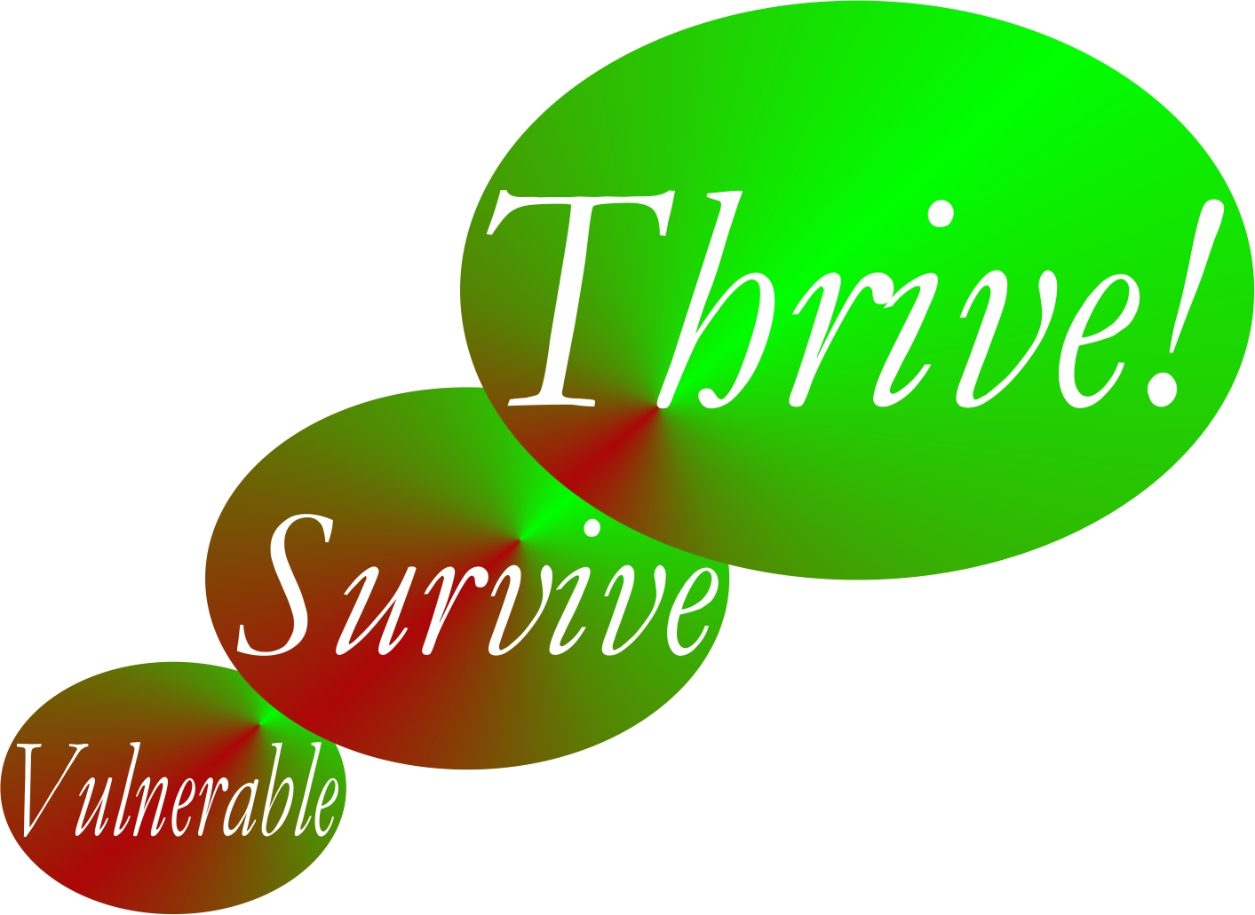

by

Gary “Chris” Christopherson

Founder, Thrive!® - Building a Thriving Future for All Forever
Founder, HealthePeople® - Building a Healthy and Thriving Future

Nelson, WI University Park, MD

Copyright © 2014 Gary Chris Christopherson

All rights reserved.
Thrive!® - People’s Guide To A Thriving Future
[For All Forever]

Complete Guide to a Thriving Future  [With Examples and Worksheets] | Complete Guide Page
Chapter 1: How to use this People’s Guide.
How to use People’s Guide to help you and your family and friends, community, country and world survive and thrive.
Chapter 2: What a thriving future will be.
What your life and our world will be in a thriving future where all survive and thrive forever.
Chapter 3: Why you and all of us must care about a thriving future.
Why you and we must care about a surviving and thriving future for you, friends and family, community, country, and world.
Chapter 4: How you and your family and friends can thrive.
How to build, achieve and sustain a surviving and thriving future for you and family and friends.
Chapter 5: How you and your community can thrive.
How to build, achieve and sustain a surviving and thriving future for you and your community.
Chapter 6: How you and your country can thrive.
How to build, achieve and sustain a surviving and thriving future for you and your country.
Chapter 7: How our world can thrive.
How to build, achieve and sustain a surviving and thriving future for our world.
Chapter 8: How the Thrive! Endeavor, you and all of us together, builds a thriving future.
How Thrive! Endeavor, you and all of us together, builds, achieves and sustains a surviving and thriving future for all forever.
Appendix: Thrive! Next Generation Toolkit.
Strategy, policy and tools for creating and sustaining large, positive change and building a thriving future.
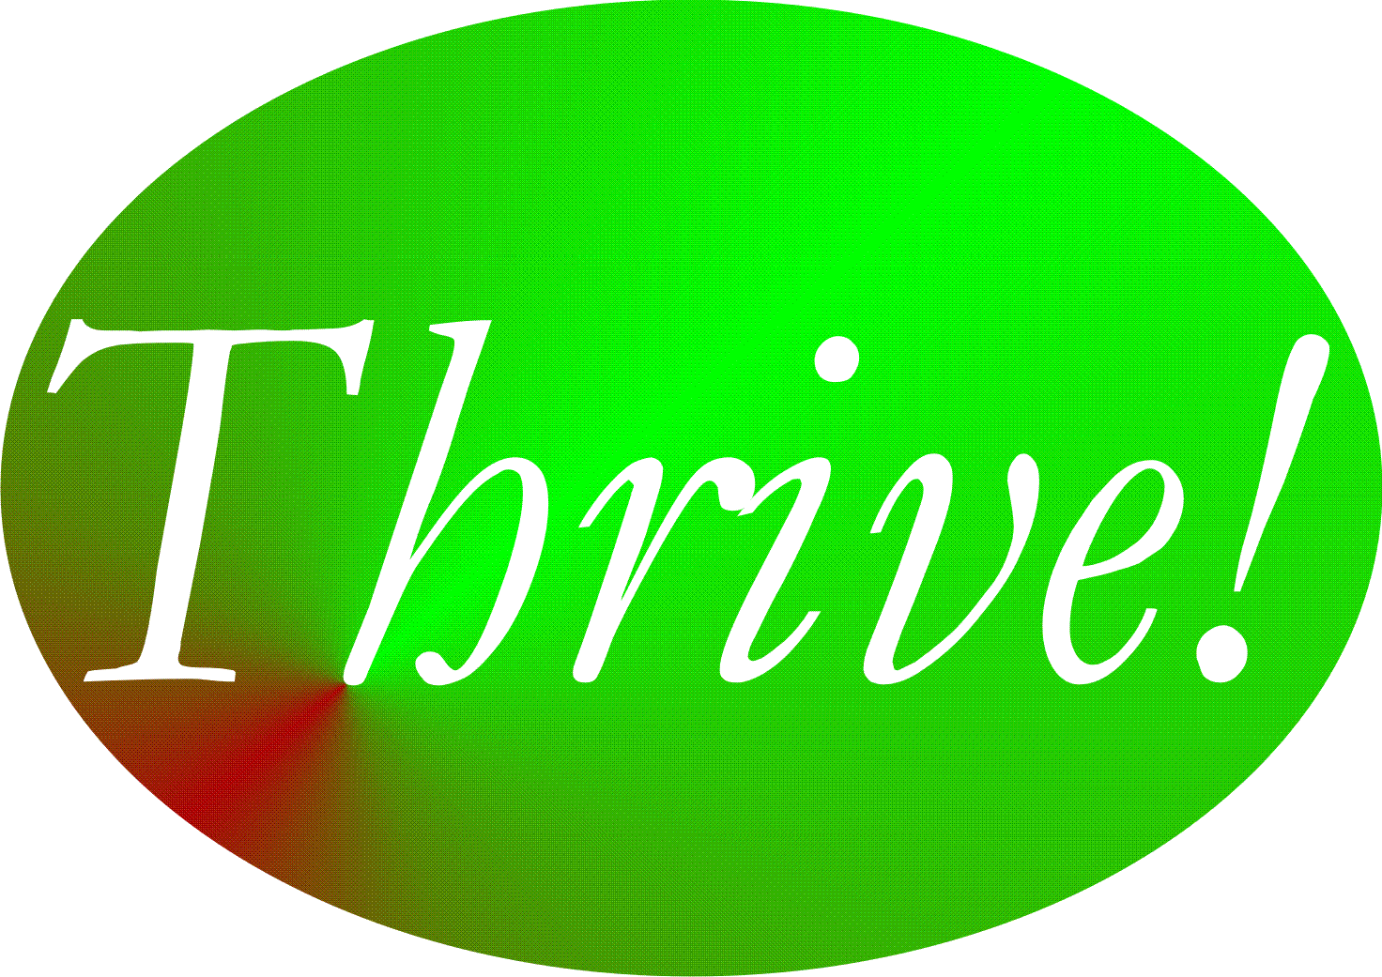

Chapter 4: How you and your family and friends can thrive.
How to build, achieve and sustain a surviving and thriving future for you and your family and friends.

Why you and your family and friends can.
Thrive!
Keep in mind that we are more capable than any time in human history. We can build a thriving future by effectively and collaboratively using all available knowledge and tools, including next generation Thrive! strategy and tools. Next generation Thrive! is different and better than anything in human history. It is achieving a thriving future at each level. It understands that people’s behavior, including yours, makes (or breaks) a thriving future. It helps people, including you, achieve the behavior that in turn achieves a thriving future at each level and for all forever.

You and your family and friends can have a surviving and thriving future. To get to that future, keep in mind that each of them is different with a different future already beginning. Each and all of them can do better whether that future appears bad or good. To build a better future, Thrive! strategy and tools have been used successfully at the personal level and on larger scales (community, country). They can work for you and the people closest to you. As they have for others, Thrive! can help you and your peoples build, achieve and sustain a surviving and thriving future.

Why you and your family and friends must.

You and your family and friends must have a surviving and thriving future. Each and all of your people must do better whether that future appears bad or good. Why? Even those that have a good future are not fully thriving, are not likely to be fully thriving in the future, and are still facing uncertainties about the long term future. You and your people all want and need that future because your and their future is endangered and because of your and their need to survive and desire to thrive. What drives each of them is their need to survive and desire to thrive in the current world and a sustainable future world. Further, because some or all of them have broken some part of their world and endangered its future, you and your people must help fix what is broken and help build a survivable and thriving future.

How to build, achieve, and sustain a surviving and thriving future for you and your family and friends.

To build a surviving and thriving future for you and your family and friends, they should be partners in this endeavor from the beginning and through each step. A collaborative approach where they jointly provide leadership, vision, motivation, strategy and successful execution probably has the greater potential to create and sustain large, positive change and a surviving and thriving future. Key to success is the strong desire to move current vulnerabilities through and beyond surviving to a sustained thriving future. Thrive! can be helpful to you and is laid out in the following steps.

Step 1.

Step 1. Current state of you and your family and friends. The first major step is to understand the current state of you and your family and friends. This “how-to” works whether it is you alone, you and your immediate family, you and a more extended family, and/or you and your friends. In this chapter, the short-hand term “your people” is used and lets you decide on whom (you alone, you and your immediate family, you and a more extended family, and/or you and your friends) you want to focus your efforts. [Note: For each step, an example is provided to give a sense of how to do that step. The example of a family provides highlights but not the full working of a step.]

a. Who are your people? Let’s first go through who are you and your people currently. Who are your people? Use Table 4.1 (end of chapter) to describe each of your people. For each person, have the person independently do a one-paragraph description in her/his own words. If the person can’t, do one for the person as best you can. Who is the person with respect to working and living? Financial situation? Eating and drinking? Housing? Protection? Education? Physical and mental health? Personal growth and development? Habitat (living environment)? Producing what? Climate? With this information on individual persons and as best you can, do a summary of your people as a whole.

Example of a family. Jane is 38, female living in small rural community in upper Midwest and working includes drilling and sanding steel. John is 39, male working as independent electrician. They are married. Children Jim is 8 years old and Joan is 15 years old. Jane works in small factory. Jane makes $25,000/year; John makes $18,000/year; both have house mortgage of $150,000. Purchase weekly food from local grocery; mainly cook evenings and weekends. Housing is 70s ranch style home. Protection by county police and by taser and pepper spray in house. Both have high school education. Jane and John have physical health problems. Jane and John have physical exercise at work; all hike most weekends. Habitat is relatively clean environment and is large river, hills, valleys. Both produce family life; Jane produces factory products; and John produces services. Climate is upper Midwest, United States.

b. How well are they? How well (surviving and thriving) are your people? Use Table 4.2a (end of chapter) to describe how well is each person. How well is each person in terms of performing well? Being well-off (financially)? Being well nourished (food and drink)? Being well housed? Being well protected (exposures, crime)? Being well educated? Being physically and mentally well? Personally growing/developing well? Living within good habitat? Not being vulnerable? Producing personal and public goods? Living within a stable, positive climate? Being sustained? With this information and as best you can, create a summary for your people as a whole. Use Table 4.2b (end of chapter) to describe how well are your people as a whole.

Answering “yes” to all indicates current surviving and thriving. Though the “yes” answers are good, there is still future work to make sure this continues. “No” answers are bad and mean there is current and future work to be done.

Example of a family. Jane’s small factory has uncertain future. John’s work is intermittent and about ¾ time. Both are low-middle income with Social Security as only retirement. They have enough food but diet has too much salt and saturated fat. Home is in decent shape but not energy efficient. Jane has some job exposure to metal dust; John may or may not have job exposure. There is only low crime in work and home area. Both graduated high school in middle of class. The family’s mental health is okay but not great. Physical health issues include Jane’s cardiovascular risks and John’s knee problems. Jane and John’s personal growth and development have essentially stopped. Habitat is beautiful and good. Family is vulnerable to job loss, health problems, children’s school problem, low retirement resources. Family is producing decent family life and good factory products and services. Climate has harsh, cold winters. Sustainability is uncertain to unlikely due to family stressors, poor retirement and savings, and growing health problems.

c. What positively or negatively impacts them? What positively or negatively impacts or is likely to impact you and your people’s surviving and thriving? Use Table 4.2a (individuals) and 4.2b (summary of your people) to describe all of the following impacts (positive and negative; current and future). What impacts your people’s performing well? Being well-off (financially)? Being well nourished (food and drink)? Being well housed? Being well protected (exposures, crime)? Being well educated? Being physically and mentally well? Personally growing/developing well? Living within good habitat? Not being vulnerable? Producing personal and public goods? Living within a stable, positive climate? Being sustained?

Good impacts improve and/or sustain surviving and thriving. If they will continue, you probably can focus on other things. If they may or may not continue, your action is needed to make them continue and/or to develop other things to compensate. Bad impacts prevent or limit surviving and thriving. If they will not continue, you probably can focus on other things. If they may or may not continue, your action is needed to stop them or to avoid or minimize their impact.

Example of a family. Jane’s small factory may be moved far away and her job may end. John’s work is not improving as there is not much local construction. Local grocery sells very little healthy food. Heating costs are rising and few incentives are available for making home energy improvements. OSHA and factory doing little to reduce job exposure to metal dust. Police force and protection may be reduced due to lower tax revenues. Re-training is expensive and not local. No real insurance coverage for mental health. Limited health insurance and limited local health care are available. No local support for personal growth and development. Community water supply is under stress. Local school has few resources for children with problems. Combination of these pressures increase risk to sustainability.

Optional.

Want more on your people’s future behavior? At this point, you should have enough good information to move to Step 2 and to develop strategy for you and your people. If you want to develop your strategy and actions further, you may want to use more of the tools and models already mentioned. See the Thrive! Next Generation Toolkit (Appendix) and optional Sections d-e below.
The following Sections d-e on your people’s future behavior are optional but can be helpful. Section d focuses on each of your people. Section e focuses on your people as a whole.

d. What is near and long term future behavior of each of your people? How are individual persons likely to behave in the near and long term future. Use Table 4.2a to describe all of the following behaviors. If no change, how will your people indivdually behave with respect to performing well? Being well-off (financially)? Being well nourished (food and drink)? Being well housed? Being well protected (exposures, crime)? Being well educated? Being physically and mentally well? Personally growing/developing well? Living within good habitat? Not being vulnerable? Producing personal and public goods? Living within a stable, positive climate? Being sustained?

Example of a family. Jane may look for another job within 35 miles. John is resisting changing professions. While income is okay now, both may lose job income and children may produce future college costs. They are unlikely to improve diet on own. They are unlikely to improve home’s energy efficiency. Jane may look for job with less occupational exposure. Jane is looking into re-training options. Family is unlikely to work on health problems. Jane and John may seek help with marriage and children stresses. Jane and John are only looking into job-related personal growth and development options. Family will continue to enjoy habitat. Family may remain vulnerable to income loss or reduction. Jane and John will talk to school about helping children. Jane and John are unlikely to act to further improve sustainability.

e. For your people as a whole, what is near/ long term future behavior with respect to thriving/surviving? With individual person information and as best you can, do the same for your people as a whole. Use Table 4.2b to describe all of the following behaviors. If no change, how will your people as a whole behave with respect to performing well? Being well-off (financially)? Being well nourished (food and drink)? Being well housed? Being well protected (exposures, crime)? Being well educated? Being physically and mentally well? Personally growing/developing well? Living within good habitat? Not being vulnerable? Producing personal and public goods? Living within a stable, positive climate? Being sustained?

Example of a family. Family may try to improve job and income situation but uncertain; family may look for help with college financing. Family is unlikely to improve diet on own. Family is unlikely to improve home’s energy efficiency. Family may try to reduce occupational exposure. Family is looking into re-training options for both. Family is unlikely to work on health problems. Family may seek help with marriage and children stresses. Family is only looking into job-related personal growth and development options. Family will continue to enjoy habitat. Family may remain vulnerable to income loss or reduction. Family will talk to school about helping children. Family is unlikely to act to further improve sustainability.

Step 2.

Step 2. Strategy to achieve you and your family and friends’ surviving and thriving future. The next major step is to develop the strategy that will help your people build and achieve a surviving and thriving future.

a. Who will your people be in the future? Who will be your future people? If there are any changes to your people that are desired or likely, take them into account. You may want to leave out persons that should not or will not be one of your people. You may want to include future persons that should or will become one of your people (for example, new children, spouse, friend).

For each new person and as you did in Step 1, briefly describe the person to the extent possible. Use Table 4.1 to describe your future people individually and as a whole. What will this person do working and living? Financial situation? Eating and drinking? Housing? Protection? Education? Physical and mental health? Personal growth and development? Quality of habitat (living environment)? Producing what? Climate? If there are likely to be changes on these characteristics with existing members of your people in the future, make these changes as best you can. Also in Table 4.1, do a summary of your people as a whole. This should provide a full picture of your future people (individually and as a whole) as it will be and as desired.

Example of a family. Jane and John may be able to stay married. Try to stay in their community and home. No new children. Children likely to leave after high school and one may go to public college. Jane’s grandfather experiencing dementia and may need to live with them or assisted living. Boating and hiking. Jane wants to work at better job and make much more than $25,000/year with cost-of-living increases. John hopes construction will increase. Weekly food from local grocery supplemented by healthier food from internet and regional health coop; cooks evenings and weekends. 70s ranch style home. Jane’s work still includes drilling and sanding steel. John’s work still puts pressure on knees. County police protection; taser and pepper spray in house. High school education. Physical exercise at work (Jane and John) and hiking on weekends (all). Habitat is river, hills, valleys. Producing family life and products/services. Climate is upper Midwest US.

b. How well should your people be in the near and long term future? How well should your people as a whole be in the future? Overall, they should be surviving and thriving. With this as a guide, you and your people choose the surviving and thriving future your people want to build and achieve. The “Thrive! strategy” will help you accomplish that.

Use Table 4.3a/b (end of chapter) to describe how well your people should be. Table 4.3a is the simpler version. Table 4.3b is the more detailed and powerful version.

From you and your people’s view and to be surviving and thriving, indicate to what extent your people should be performing well. Be well-off (financially). Be well nourished (food and drink). Be well housed. Be well protected (exposures, crime). Be well educated. Be physically and mentally well. Be personally growing/developing well. Be living within good habitat. Not be vulnerable. Be producing personal and public goods. Be living within a stable, positive climate. Be sustained. Again, your people should be surviving and thriving.

Example of a family. Jane has better job with better income, more certainty, pension, health benefits and no occupational exposure. John likes being electrician and continues but with more construction work. Jane and John’s employers provide better income security. Family has enough food but needs healthier diet, including reduced salt and saturated fat. Family improves home energy efficiency. Low crime is in work and home area. Jane and John have improved job skills for new and future jobs. Family improves mental health; Jane and John’s job improvement helps. Family has improved physical and mental health by eating better, lowering stress, changing jobs, getting health benefits, and seeking better health care for more complex health problems. Family has improved personal growth and development at least in job/career. Habitat is beautiful and good. Family minimizes vulnerability to job loss, health problems, low retirement resources. Children’s school situation is good. Family produces thriving family life and high quality work products. Family is more energy efficient, especially for heating, to help with harsh, cold winters. Family takes positive advantage of climate. Family may move to more positive climate. Family ensures sustainability by working though marital issues, working through children’s school issues, minimizing family stressors, improve retirement and savings, and improve health.

c. What has to change externally and internally to achieve your people’s thriving future? What has to change externally (outside your people) and internally (within your people) to progress from your people’s current status to achieve your desired surviving and thriving status? In Step 1, you identified what positively and negatively impacts or is likely to impact your people. Update those, taking into account any changes to who are your people in the future.

Given those, what has to change externally and internally to achieve a surviving and thriving future? Use Table 4.3a/b to describe all that has to change for the following. To achieve performing well? Being well-off (financially)? Being well nourished (food and drink)? Being well housed? Being well protected (exposures, crime)? Being well educated? Being physically and mentally well? Personally growing/developing well? Living within good habitat? Not being vulnerable? Producing personal and public goods? Living within a stable, positive climate? Being sustained?

Good changes improve and/or sustain surviving and thriving. Bad changes prevent and/or limit surviving and thriving.

Example of a family. Jane needs employer (current or a new one) to give her job with better income, more certainty, pension, health benefits and no occupational exposure. John needs home and business owners to do more construction and repair. Need no-cost nutritionist/dietician to help buying/preparing healthier diet, including reduced salt and saturated fat. Need financial incentives to improve home energy efficiency, especially for heating during cold, harsh winters. Need police to continue to keep crime low in work and home area. Need physically and financially accessible training program to improve job skills for new and future jobs. Need physically and financially accessible mental health and physical health services that can successfully treat fairly complex problems. Need accessible and affordable healthy food source. Need local heating fuel supplier to provide lower price heating fuel. Need community, state and Federal social safety programs to receive stronger support and provide more assurance to family within 6 months. Need school and counselors to work successfully with Jane, John, Jim and Joan on improving children’s school situation.

d. What actions by your people are needed to achieve their thriving future? What internal actions (by you and your people) and external actions (by others) are needed to bring about the needed external and internal changes (identified in “c”) that improve your people’s current status enough to achieve the desired surviving and thriving status? [See Figure 4.1]

External actions by others. There are very important external actions that are needed to support the Thrive! strategy. You already identified what has to change externally to achieve your people’s surviving and thriving future. What external actions by others will bring about the needed changes?

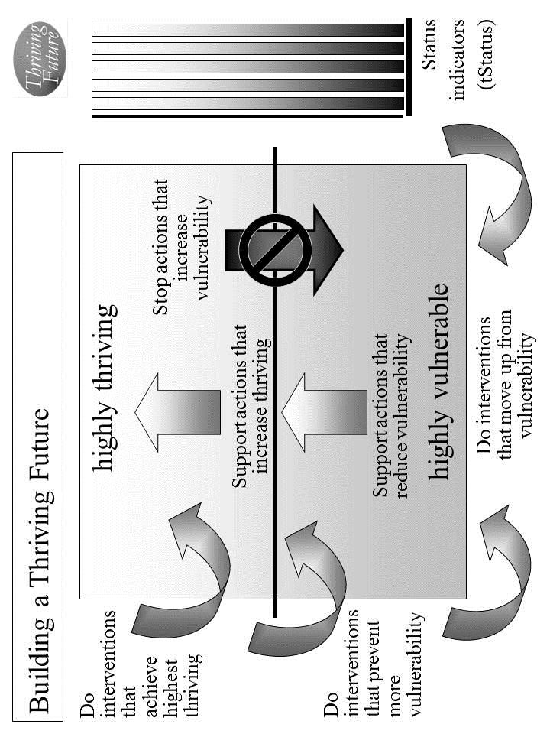
Figure 4.1. Building a Thriving Future.

Use Table 4.3a/b to describe all the external actions to be taken.

Identify external actions by others that support good changes that will help improve and/or sustain surviving and thriving. If good changes are likely to occur, together with others support them. If good changes are not likely to occur, together with others support them and develop other good changes to compensate.

Identify external actions by others that stop bad changes that prevent or limit surviving and thriving. If bad changes are not likely to occur, together with others ensure that they do not. If bad changes are likely to occur, together with others change them, stop them or avoid/reduce their impact.

Example. Jane’s employer may leave area and take her job with it but other employers may be open to hiring her. Home owners and businesses may reduce or increase their business with John. The local grocery store may carry less or more healthy food at affordable prices. Federal, state, local or private utilities may provide lesser or greater financial incentives for energy efficiency; local heating fuel supplier may raise or lower prices. Local government could reduce or increase support for police; police may be less or more effective at protecting. Accessible re-training programs may become less or more available (distance, hours, cost). Nearby physical and mental health providers may reduce/increase services and/or may raise/lower costs. In addition to local grocery, internet grocery may reduce/increase availability of affordable healthy foods. School and its staff provide less/greater support to family. Social safety net becomes less/ more helpful and provides less/more assurance to families like theirs.

Internal actions by your people. There are very important internal actions by you and your people that support the Thrive! strategy. Individual members and your people as a whole should support your strategy to ensure your people (individually and as a whole) are performing well. Being well-off (financially). Being well nourished (food and drink). Being well housed. Being well protected (exposures, crime). Being well educated. Being physically and mentally well. Personally growing/developing well. Living within good habitat. Not being vulnerable. Producing personal and public goods. Living within a stable, positive climate. Being sustained.

Use Table 4.3a/b to describe all the internal actions to be taken.

Identify internal actions by your people that support good changes that will help improve and/or sustain surviving and thriving. If good changes are likely to occur, support them. If good changes are not likely to occur, support them and develop other good changes to compensate. [Use Table 4.3a/b]

Identify internal actions by your people that stop bad changes that prevent or limit surviving and thriving. If bad changes are not likely to occur, ensure that they do not. If bad changes are likely to occur, change them, stop them or avoid/reduce their impact.

Example. Jane will more actively seek and change jobs. John will market himself more and travel more. Family will shop for and help prepare healthier diet. Both avoid eating out in less healthy restaurants. Family will work to improve home energy efficiency. Family will avoid situations where crime is more likely. Jane and John will go through re-training. Family will assist and support each other to improve mental health. Family will work together to improve physical and mental health. Family will improve personal growth and development. Family will enjoy the beautiful and good habitat. Family will work with school and counselors and with children to improve children’s school situation. Family will join together to produce thriving family life. Jane and John will produce high quality work products/services. Family will increase heating efficiency to help with harsh, cold winters. Family will take better advantage of climate and may consider moving to more positive climate. Family will ensure sustainability to extent it can internally.

e. Overall Thrive! strategy and actions. Your overall Thrive! strategy and actions need to be documented and agreed to by your people. Different members of your people will take on different responsibilities. For each action, designate who of your people will do what to/with whom, where, when, and with what result. [See example below.] Use Table 4.3a/b to document these actions and responsibilities. [See example table at end of Chapter.]

Example of a family surviving and somewhat thriving. [Who will do what to/with whom, where, when, and with what result?] See Example Thrive! Strategy and Action Plan in list and table at end of Chapter. With these actions, family would be surviving and doing better but would not yet have achieved full thriving.
- Jane will more actively seek new job starting next Monday and, if feasible, change jobs to one with better income, more certainty, pension, health benefits and no occupational exposure within 3 months. John likes being electrician and continues but will market himself more and travel more within next two weeks. Community has begun seeking new employers with the intent of having 1000 new jobs within 12 months.
- Family will shop for and help prepare healthier diet, including reduced salt and saturated fat, starting next Saturday. Family will avoid eating out in less healthy restaurants from today forward. Local grocery agrees to add more healthy food, on trial basis, within 30 days.
- Family will work to improve home energy efficiency doing as much as they can themselves and starting immediately. State may provide new energy efficiency incentives within 12 months but needs substantial public pressure within next 2 months.
- Family will avoid situations where crime is more likely starting next weekend. Low crime in work and home area may be enough. Community commits to sufficient funding to sustain effective police protection from this time forward.
- Jane and John will go through re-training to improve job skills for new and future jobs within next 6 months. Nearby community college will add re-training programs starting this fall session.
- Family will assist and support each other to improve mental health starting immediately. Job change and improvement will help (see above). Family will work together to improve physical and mental health by eating better, lowering stress, changing or improving jobs, getting health benefits, and seeking better health care from better providers for more complex health problems starting immediately. Local health provider will add more mental health services within 12 months. More public health insurance programs are available that include physical and mental health services within 6 months.
- Family will improve personal growth and development, at least in job/career and re-training (see above).
- Family will enjoy the beautiful and good habitat starting next weekend. Family will do volunteer work on protecting environment.
- Jane and John will improve income security (see above). Family will work with school and counselors and with children to improve children’s school situation starting with new school year.
- Family will join together to produce thriving family life (see above). Jane and John will produce high quality work products/services (see above). School agrees to provide more support to children to produce better learning starting with new school year.
- Family will be more energy efficient, especially for heating, which will help with harsh, cold winters starting this winter. Local heating fuel supplier provides lower price heating fuel to avoid more competition effective immediately. Family will take better advantage of climate starting immediately. If they don’t, they will explore moving to more positive climate within 2 years.
- Family will ensure sustainability by getting better job situation, working though marital issues, working through children’s school issues, minimizing family stressors, improve retirement and savings, and improve health within 12 months. Community, state and Federal social safety programs receive stronger support and can provide more assurance to family within 6 months.

This is your Thrive! Strategy and Action Plan. As the strategy is executed, you strategy, actions and results should be updated.

Periodically, you and your people should assess your strategies/actions near and long term impact on near and long term surviving and thriving.

When a) your strategies and actions are not building and sustaining a thriving future and/or b) there are changes in the external world and in your people, you and your people should adjust your overall Thrive! Strategy and Action Plan.

The key is to successfully execute your strategy and actions and to build a near and long term surviving and thriving future. Each and all must successfully carry out the assigned action. That is, each/all must successfully do what is required to/with whoever is required, where required, when required, and with what needed/desired result.

A Thrive! Strategy and Action Plan is only as good as its successful execution and successful achievement of the desired outcome - a surviving and thriving future.

But, we want a thriving future for you and your family and friends. To build, achieve and sustain a surviving and thriving future, the Thrive! Strategy and Action Plan should be more like the following example:

Example of you and your family surviving and thriving. [Who will do what to/with whom, where, when, and with what result?] Starting immediately, you and your family and friends build, achieve, and sustain a surviving and thriving future, including:
- Performing well. Starting immediately, you and your family and friends act to ensure, within the next 10 years, a) all (who are able and not appropriately retired) can work and earn a living income sufficient to survive and thrive and b) all have sufficient resources for and are living, recreating, learning so that they are surviving and thriving to maximum extent feasible.
- Being well-off (financially). Starting immediately, you and your family and friends act to ensure, within the next 10 years, a) all have sufficient income/resources to survive and thrive.
- Being well nourished (food and drink). Starting immediately, you and your family and friends act to ensure, within the next 5 years, that all have access to, be able to afford and consume healthy foods enough to survive and thrive.
- Being well housed. Starting immediately, you and your family and friends act to ensure, within the next 10 years, all have access to, be able to afford and live in adequate and preferably high performing housing that supports surviving and thriving.
- Being well protected (exposures, crime). Starting immediately, you and your family and friends act to ensure, within the next 5 years, environmental exposures in home, workplace and elsewhere are minimized so as to not prevent surviving and thriving.
- Being well educated. Starting immediately, you and your family and friends act to ensure, within the next 10 years, all are educated to the full extent of their abilities, needs and desires and to support their surviving and thriving.
- Being physically and mentally well. Starting immediately, you and your family and friends act to ensure, within the next 5 years, a) all receive the optimal health support to ensure, within the next 20 years, surviving and thriving and b) physical and mental health is optimized to best ensure surviving and thriving.
- Personally growing/developing well. Starting immediately, you and your family and friends act to ensure, within the next 10 years, all people are personally growing and developing to best ensure surviving and thriving.
- Living within good habitat. Starting immediately, you and your family and friends act to ensure, within the next 20 years, a) all have access to habitat that best supports their surviving and thriving.
- Not being vulnerable. Starting immediately, you and your family and friends act to ensure, within the next 20 years, all, if vulnerable, are vulnerable only to the minimum extent feasible.
- Producing personal and public goods. Starting immediately, you and your family and friends act to ensure, within the next 10 years, all produce personal and public goods (including personal income/resources, housing, food and drink, energy, education, health, protection, personal growth and development, and habitat) so as to support surviving and thriving for all.
- Living within a stable, positive climate. Starting immediately, you and your family and friends act to ensure, within the next 2years, all behave so as to avoid negative impacts and support positive impacts so as to help ensure a stable, positive climate.
- Being sustained. Starting immediately, you and your family and friends act to ensure, within the next 5 years, all behave so as to ensure the sustainability of you and your family and friends.
Thrive! Strategy and Action Plan (Example of surviving and somewhat thriving).
Thriving and Surviving | How well (surviving/ thriving) should your people as a whole be in near/long term future? | External/internal changes needed to achieve surviving and thriving future | Actions by your people and others  Who will do what to/with whom, where, when, and with what result?
Performing (live/work/ play) well? | Jane has better job with better income, more certainty, pension, health benefits and no occupational exposure. John likes being electrician and continues but with more construction work. | External: Jane needs employer (current or a new one) to give her job with better income, more certainty, pension, health benefits and no occupational exposure. John needs home and business owners to do more construction and repair. | External by others: Community has begun seeking new employers with the intent of having 1000 new jobs within 12 months.
Performing (live/work/ play) well? |  |  | Internal by your people: Jane will talk to current employer about higher pay and change in job to avoid exposure. John will approach home and business owners to get more jobs.
Performing (live/work/ play) well? |  | Internal: | Internal by your people: Jane will more actively seek new job starting next Monday and, if feasible, change jobs to one with better income, more certainty, pension, health benefits and no occupational exposure within 3 months. John likes being electrician and continues but will market himself more and travel more within next two weeks.
Well-off? | Jane and John’s employers provide better income security. | External: Need employers to provide better income security. | External by others:  See above
Well-off? | Jane and John’s employers provide better income security. | External: Need employers to provide better income security. | Internal by your people: See above
Well-off? | Jane and John’s employers provide better income security. | Internal: | Internal by your people: See above
Well nourished? | Family has enough food but needs healthier diet, including reduced salt and saturated fat. | External: Need no-cost nutritionist/ dietician to help buying/preparing healthier diet, including reduced salt and saturated fat. situation. Need accessible and affordable healthy food source. | External by others:  Local grocery agrees to add more healthy food, on trial basis, within 30 days.
Well nourished? |  |  | Internal by your people:
Well nourished? |  | Internal: | Internal by your people: Family will shop for and help prepare healthier diet, including reduced salt and saturated fat, starting next Saturday. Family will avoid eating out in less healthy restaurants from today forward.
Well housed | Family improves home energy efficiency. | External: Need financial incentives to improve home energy efficiency, especially for heating during cold, harsh winters. | External by others:  State may provide new energy efficiency incentives within 12 months but needs substantial public pressure within next 2 months.
Well housed | Family improves home energy efficiency. |  | Internal by your people:
Well housed | Family improves home energy efficiency. | Internal: | Internal by your people: Family will work to improve home energy efficiency doing as much as they can themselves and starting immediately.
Well protected? | Low crime is in work and home area. | External: Need police to continue to keep crime low in work and home area. | External by others:  Low crime in work and home area may be enough. Community commits to sufficient funding to sustain effective police protection from this time forward.
Well protected? | Low crime is in work and home area. |  | Internal by your people:
Well protected? | Low crime is in work and home area. | Internal: | Internal by your people: Family will avoid situations where crime is more likely starting next weekend.
Well educated? | Jane and John have improved job skills for new and future jobs. | External: Need physically and financially accessible training program to improve job skills for new and future jobs. | External by others:  Nearby community college will add re-training programs starting this fall session.
Well educated? |  |  | Internal by your people:
Well educated? |  | Internal: | Internal by your people: Jane and John will go through re-training to improve job skills for new and future jobs within next 6 months.
Physically/ mentally well? | Family improves mental health; Jane and John’s job improvement helps. Family has improved physical and mental health by eating better, lowering stress, changing jobs, getting health benefits, and seeking better health care for more complex health problems. | External: Need physically and financially accessible mental health and physical health services that can successfully treat fairly complex problems. | External by others:  Local health provider will add more mental health services within 12 months. More public health insurance programs are available that include physical and mental health services within 6 months.
Physically/ mentally well? |  |  | Internal by your people:
Physically/ mentally well? |  | Internal: | Internal by your people: Family will assist and support each other to improve mental health starting immediately. Job change and improvement will help (see above). Family will work together to improve physical and mental health by eating better, lowering stress, changing or improving jobs, getting health benefits, and seeking better health care from better providers for more complex health problems starting immediately.
Growing/ developing well? | Family has improved personal growth and development at least in job/career. | External: Need physically and financially accessible re-training programs. | External by others:
Growing/ developing well? |  |  | Internal by your people:
Growing/ developing well? |  | Internal: | Internal by your people: Family will improve personal growth and development, at least in job/career and re-training (see above)
Living in good habitat? | Habitat is beautiful and good. | External: No change needed, except to sustain habitat. | External by others:
Living in good habitat? | Habitat is beautiful and good. | External: No change needed, except to sustain habitat. | Internal by your people: Family will do volunteer work on protecting environment.
Living in good habitat? | Habitat is beautiful and good. | Internal: | Internal by your people: Family will enjoy the beautiful and good habitat starting next weekend.
Not vulnerable? | Family minimizes vulnerability to job loss, health problems, low retirement resources. Children’s school situation is good. | External: Need school and counselors to work successfully with Jane, John, Jim and Joan on improving children’s school | External by others:
Not vulnerable? |  |  | Internal by your people:
Not vulnerable? |  | Internal: | Internal by your people: Jane and John will improve income security (see above). Family will work with school and counselors and with children to improve children’s school situation starting with new school year.
Producing personal/ public goods? | Family produces thriving family life and high quality work products. | External: See above | External by others:  School agrees to provide more support to children to produce better learning starting with new school year.
Producing personal/ public goods? |  | External: See above | Internal by your people:
Producing personal/ public goods? |  | Internal: | Internal by your people: Family will join together to produce thriving family life (see above). Jane and John will produce high quality work products/services (see above).
Stable, positive climate? | Family is more energy efficient, especially for heating, to help with harsh, cold winters. Family takes positive advantage of climate. Family may move to more positive climate. | External: Need local heating fuel supplier to provide lower price heating fuel. | External by others:  Local heating fuel supplier provides lower price heating fuel to avoid more competition effective immediately.
Stable, positive climate? |  |  | Internal by your people:
Stable, positive climate? |  | Internal: | Internal by your people: Family will be more energy efficient, especially for heating, which will help with harsh, cold winters starting this winter. Family will take better advantage of climate starting immediately. If they don’t, they will explore moving to more positive climate within 2 years.
Sustainable? | Family ensures sustainability by working though marital issues, working through children’s school issues, minimizing family stressors, improve retirement and savings, and improve health. | External: Need community, state and Federal social safety programs to receive stronger support and provide more assurance to family within 6 months. Need school and counselors to work successfully with Jane, John, Jim and Joan on improving children’s school situation. | External by others:  Community, state and Federal social safety programs receive stronger support and can provide more assurance to family within 6 months.
Sustainable? |  |  | Internal by your people:
Sustainable? |  | Internal: | Internal by your people: Family will ensure sustainability by getting better job situation, working though marital issues, working through children’s school issues, minimizing family stressors, improve retirement and savings, and improve health within 12 months.
Table 4.3b. How well should your future people as a whole be in near/long term future? What external/internal changes are needed to achieve your people’s thriving future? To make this happen, what external/internal actions are needed?

Current and Future Persons (name) | For each person, have the person independently do a one-paragraph description in her/his own words. If the person can’t, do one for the person. Cover things like work/living/playing, financial situation, eating/drinking, housing, protection, education, physical/mental health, growth/development, habitat, producing what, and climate. Enter the descriptions into this worksheet/table. Do a summary of your people as a whole.
Your current and future people as a whole. [Summary]
Table 4.1. Who are your current and future people?
Current/Future Person: ___________________ (Do for each person)
Thriving and Surviving | How well (surviving/ thriving) is the person? | What positively/ negatively impacts her/his thriving/ surviving? | [Optional] If no change, what is her/his near/ long term future behavior as to thriving/ surviving?
Performing (live/work/play) well?
Well-off?
Well nourished?
Well housed?
Well protected?
Well educated?
Physically/ mentally well?
Growing/ developing well?
Living in good habitat?
Not vulnerable?
Producing personal/ public goods?
Stable, positive climate?
Sustainable?
Table 4.2a. How well (surviving/thriving) is the person? What positively/negatively impacts the person? What is her/his near/long term future behavior?
Thriving and Surviving | How well (surviving/ thriving) are your people as a whole? | What positively/ negatively impacts their thriving/ surviving? | [Optional] What is their near/ long term future behavior as to thriving/ surviving?
Performing (live/work/play) well?
Well-off?
Well nourished?
Well housed?
Well protected?
Well educated?
Physically/ mentally well?
Growing/ developing well?
Living in good habitat?
Not vulnerable?
Producing personal/ public goods?
Stable, positive climate?
Sustainable?
Table 4.2b. How well (surviving/thriving) are your people as a whole? What positively/negatively impacts them? If no change, what is their near/long term future behavior?
Thriving and Surviving | How well (surviving/ thriving) should your people as a whole be in near/long term future? | External/ internal changes needed to achieve thriving/ surviving future | External actions by others - Who externally will do what to/with whom, where, when, and with what result? How to make that happen? | Internal actions by your people -  Who of your people will do what to/with whom, where, when, and with what result
Performing (live/work/ play) well?
Well-off?
Well nourished?
Well housed?
Well protected?
Well educated?
Physically/ mentally well?
Growing/ developing well?
Living in good habitat?
Not vulnerable?
Producing personal/public goods?
Stable, positive climate?
Sustainable?
Table 4.3a. Thrive! Strategy and Action Plan. How well (surviving/thriving) should your people as a whole be in near/long term future? What external/internal changes are needed to achieve your people’s thriving future? To make this happen, what external/internal actions are needed?

Thriving and Surviving | How well (surviving/ thriving) should your people as a whole be in near/long term future? | External/internal changes needed to achieve surviving and thriving future | Actions by your people and others  Who will do what to/with whom, where, when, and with what result?
Performing (live/work/ play) well? |  | External: | External by others:
Performing (live/work/ play) well? |  | External: | Internal by your people:
Performing (live/work/ play) well? |  | Internal: | Internal by your people:
Well-off? |  | External: | External by others:
Well-off? |  | External: | Internal by your people:
Well-off? |  | Internal: | Internal by your people:
Well nourished? |  | External: | External by others:
Well nourished? |  | External: | Internal by your people:
Well nourished? |  | Internal: | Internal by your people:
Well housed |  | External: | External by others:
Well housed |  | External: | Internal by your people:
Well housed |  | Internal: | Internal by your people:
Well protected? |  | External: | External by others:
Well protected? |  | External: | Internal by your people:
Well protected? |  | Internal: | Internal by your people:
Well educated? |  | External: | External by others:
Well educated? |  | External: | Internal by your people:
Well educated? |  | Internal: | Internal by your people:

Physically/ mentally well? |  | External: | External by others:
Physically/ mentally well? |  | External: | Internal by your people:
Physically/ mentally well? |  | Internal: | Internal by your people:
Growing/ developing well? |  | External: | External by others:
Growing/ developing well? |  | External: | Internal by your people:
Growing/ developing well? |  | Internal: | Internal by your people:
Living in good habitat? |  | External: | External by others:
Living in good habitat? |  | External: | Internal by your people:
Living in good habitat? |  | Internal: | Internal by your people:
Not vulnerable? |  | External: | External by others:
Not vulnerable? |  | External: | Internal by your people:
Not vulnerable? |  | Internal: | Internal by your people:
Producing personal/ public goods? |  | External: | External by others:
Producing personal/ public goods? |  | External: | Internal by your people:
Producing personal/ public goods? |  | Internal: | Internal by your people:
Stable, positive climate? |  | External: | External by others:
Stable, positive climate? |  | External: | Internal by your people:
Stable, positive climate? |  | Internal: | Internal by your people:
Sustainable? |  | External: | External by others:
Sustainable? |  | External: | Internal by your people:
Sustainable? |  | Internal: | Internal by your people:
Table 4.3b. Thrive! Strategy and Action Plan. How well should your future people as a whole be in near/long term future? What external/internal changes are needed to achieve your people’s thriving future? To make this happen, what external/internal actions are needed?

The following strategy is adapted from the Thrive! Next Generation Toolkit contained in the Appendix. It is customized to help you and your people build, achieve and sustain a surviving and thriving future. More is available in Thrive! - Building a Thriving Future - a manual providing greater depth on strategy and tools and is available via www.Amazon.com or free download from www.ThrivingFuture.org.
Uses the Toolkit’s “Systems Model (including Ideal Systems)”.
Free download of larger, fillable worksheets at www.ThrivingFuture.org
Uses the Toolkit’s “Status Model”.
Free download of larger, fillable worksheets at www.ThrivingFuture.org
Free download of larger, fillable worksheets at www.ThrivingFuture.org
Using the full Thrive! Next Generation Toolkit (Appendix) may be useful because it includes more strategy, policy and tools for creating and sustaining large, positive change and building a surviving and thriving future. You might also want to use Thrive! - Building a Thriving Future - a manual providing greater depth on strategy and tools and available via www.Amazon.com or as free download from www.ThrivingFuture.org. If you want to dig deeper, you may want to use the Behavioral Effectiveness Model (BEM) to more deeply assess what your people will do (behavior) in the future. What this does is assess how your people’s motivation and ability will impact future behavior and how actions by people outside your people will impact your people’s motivation, ability and behavior. A full description of BEM and how to use it is included in the Appendix.
Uses the Toolkit’s “Person Model”.
Uses the Toolkit’s “Population Model”.
Uses the Toolkit’s “Systems Model (including Ideal Systems)”.
Uses the Toolkit’s “Status Model”.
Free download of larger, fillable worksheets at www.ThrivingFuture.org
Uses the Toolkit’s “Performance Improvement Model” and “via Model”.
Uses the Toolkit’s “Strategy Model”.
An action is defined as “who will do what to/with whom, where, when, and with what result.”
At this point, you should have enough good information to execute you and your people’s Thrive! Strategy and Action Plan. If you want to develop your strategy and actions further, you may want to use more of the tools and models already mentioned and the Thrive! Next Generation Toolkit (Appendix). The full Thrive! Next Generation Toolkit includes strategy, policy and tools for creating and sustaining large, positive change and building a thriving future. You might also want to use Thrive! - Building a Thriving Future - a manual providing greater depth on strategy and tools and available via www.Amazon.com or as a free download from www.ThrivingFuture.org. If you want to dig deeper, you may want to use the Behavioral Effectiveness Model (BEM) to more deeply assess what your people will do (behavior) in the future. What this does is assess how your people’s motivation and ability will impact future behavior and how actions by people outside your people will impact your people’s motivation, ability and behavior. A full description of BEM and how to use it is included in the Appendix.

